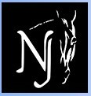
Dressage at Stone Tavern I & II
626 Route 524, Allentown, NJ 08501
September 2 – 3, USEF/USDF #329354 – Level #3
September 4, USEF/USDF #315027 – Level #2

Official Qualifying Competition for the 2017 Adequan FEI North America Junior and Young Rider Championships presented by Gotham North; the 2017 USEF Pony Rider Dressage National Championship; 2017 AGCO/USEF Junior and Young Rider Dressage National Championships; and the 2017 USEF Young Adult “Brentina Cup” Dressage National Championship
2016 Col. Bengt Ljungquist Memorial Championship (BLM) Qualifying Competition
2017 Great American Insurance Group/USDF Qualifying Competition
2016 Great American Insurance Group/USDF Breeders’ Championship Series

SHOW DATES OPENING DATE CLOSING DATE
September 2 -4, 2016 July 19, 2016 August 19, 2016

MANAGERS: SECRETARY:
Jane Cory (Friday – Sunday) Debra McCluskey
215-262-2870 609-203-6142
Jane@pleasanthollow.com DebraLMccluskey@yahoo.com
Jennifer Bateman (Sunday only)
215-804-6432 MAIL ENTRIES TO:
Horse Park of NJ, 626 Route 524
SHOW MANAGEMENT: Allentown, NJ 08501
Horse Park of NJ
www.horseparkofnewjersey.com VET:
Foundation Equine – on call
SHOW COMMITTEE: 609-291-0535
Lynn Mathews
Debra McCluskey FARRIER:
Jennifer Bateman Tom Picinich – on call
732-685-1509
SHOW OFFICE PHONE:
215-804-6432(show days only) EMT SERVICES:
New Egypt Ambulance
STABLE MANAGER:
TBA TD: Tara Bowles, R, NJ

JUDGES: Kem Barbosa, S, NJ Breed Show Judge:
Lisa Schmidt, S, NJ Susan Graham-White, r, MD
Janice Conlon, R, MD

DRESSAGE AT STONE TAVERN I CLASS LIST
Every class offered herein which is covered by the rules and specifications of the current USEF Rule Book will be conducted and judged in accordance therewith. USEF tests, Current editions.
Friday, September 2nd | Saturday, September 3rd
USEF Tests, current editions | USEF Tests, current editions
101 Training Level Test 1-Open | 201 Training Level Test 1-Open
102 Training Level Test 2-Open /BLM | 202 Training Level Test 2-Open/BLM
103 Training Level Test 3-O/GAIG/USDFQ | 203 Training Level Test 3-O/GAIG/USDFQ
104 Training Level Rider Test | 204 Training Level Rider Test
111 First Level Test 1-Open | 211 First Level Test 1-Open
112 First Level Test 2-Open/BLM | 212 First Level Test 2- Open/BLM
113 First Level Test 3- O/GAIG/USDFQ | 213 First Level Test 3- O/GAIG/USDFQ
114 First Level Rider Test | 214 First Level Rider Test
121 Second Level Test 1-Open | 221 Second Level Test 1- Open
122 Second Level Test 2-Open/BLM | 222 Second Level Test 2-Open/BLM
123 Second Level Test 3- O/GAIG/USDFQ | 223 Second Level Test 3-O/GAIG/USDFQ/Dover Medal
124 Second Level Rider Test | 224 Second Level Rider Test
131 Third Level Test 1-Open | 231 Third Level Test 1-Open
132 Third Level Test 2-Open/BLM | 232 Third Level Test 2-Open/BLM
133 Third Level Test 3-Open/GAIG/USDFQ | 233 Third Level Test 3-O/GAIG/USDFQ
141 Fourth Level Test 1-Open | 241 Fourth Level Test 1-Open
142 Fourth Level Test 2-Open/BLM | 242 Fourth Level Test 2-Open/BLM
143 Fourth Level Test 3 – O/GAIAG/USDFQ | 243 Fourth Level Test 3 O/GAIG/USDFQ
150 FEI PSG-Open/BLM/GAIG/USDFQ | 250 FEI PSG-Open/BLM/GAIG/USDFQ
151 FEI Intermed I-Open/BLM/GAIG/USDFQ | 251 FEI I- I-O/BLM/GAIG/USDFQ
152 FEI Intermed II-Open/BLM/GAIG/USDFQ | 252 FEI I - II-Open/BLM/GAIG/USDFQ
153 FEI Gr Prix Test-Open/BLM/GAIG/USDFQ | 253 FEI GP Test-O/BLM/GAIG/USDFQ
154 FEI Test for 5 year olds – Open | 254 FEI Test for 5 year olds – Open
154.1FEI Test for 6 year olds – Open | 254.1 FEI Test for 6 year olds – Open
155 FEI YR Team Test - O/USEFNAJYRCQ‡ | 255 FEI YR Ind. Test – O/ USEFNAJYRCQ‡
156 FEI JR Team Test – O/GAIG/ USEFNAJYRCQ‡ | 256 FEI JR Individual Test –O /USEFNAJYRCQ‡
157 FEI TOC+ - Open | 257 FEI TOC+ - Open
158 Para Equestrian- TOC + - Open | 258 Para Equestrian- TOC + - Open
159 USEF 4 yr old test – Open | 259 USEF 4 yr old test – Open
160 USDF MFS- Open/(1st-4th)BLM/GAIG/USDFQ | 260 USDF MFS-O/(1st-4th)BLM/GAIG/USDFQ
161 USDF Pas de Deux+ | 261 USDF Pas De Deux+ - Open
170 FEI MFS-O/BLM/GAIG/USDFQ+ | 270 FEI MFS-O/BLM/GAIG/USDFQ+
171 FEI Pony Team Test – O/USEFNAJYRCQ‡ | 271 FEI YR Freestyle – Open
171.1FEI Pony Individual Test – O/USEFNAJYRCQ‡ | 271.1 FEI JR Freestyle – Open
172 USEF Brentina’s Cup Test – Open | 272 FEI Grand Prix 16-25 Test O/USEFNAJYRCQ‡
173 USEF Dressage Seat Equitation – Open/USEFQ‡ | 273 Dressage Seat Equitation – O/USEFQ‡
174 USEF Developing Horse PSG – Open | 274 Developing Horse PSG – Open
175 USEF Developing Horse Grand Prix – Open  200 USDF Introductory Level TOC+ | 275 Developing Horse Grand Prix – Open  300 USDF Introductory Level TOC+
+ Please specify test of choice. TOC must be test not be offered. ‡ - USEFNAJYRC Qualifying tests are double judged.
Opportunity Classes offered*
101.1 Opportunity Training Level Test 1(Fri) 201.1 Opportunity Training Level Test 1 (Sat)
103.3 Opportunity Training Level Test 3(Fri) 203.3 Opportunity Training Level Test 3 (Sat)

*Horses and/or riders entered in Opportunity Classes can cross enter into the recognized classes but require the rider, owner, or horse to have memberships in USEF/USDF and pay the USEF drug fee. Opportunity Classes are not eligible for any USEF/USDF awards or qualifications. Opportunity Classes do not require the rider, owner, or horse to have memberships in USEF/USDF or pay the USEF drug free.
DRESSAGE AT STONE TAVERN II CLASS LIST
Every class offered herein which is covered by the rules and specifications of the current USEF Rule Book will be conducted and judged in accordance therewith. USEF tests, Current editions.
Sunday, September 4th
01  02 | Training Level Test 1-Open  Training Level Test 2-Open /BLM
03 | Training Level Test 3- O/GAIG/USDFQ
04 | Training Level Rider Test
11 | First Level Test 1-Open
12 | First Level Test 2-Open/BLM
13 | First Level Test 3- O/GAIG/USDFQ
14 | First Level Rider Test
21 | Second Level Test 1-Open
22 | Second Level Test 2-Open/BLM
23  24 | Second Level Test 3- O/GAIG/USDFQ/Dover Medal  Second Level Rider Test
31 | Third Level Test 1-Open
32 | Third Level Test 2-Open/BLM
33 | Third Level Test 3-Open/GAIG/USDFQ
41 | Fourth Level Test 1-Open
42 | Fourth Level Test 2-Open/BLM
43 | Fourth Level Test 3 – O/GAIG/USDFQ
50 | FEI PSG-Open/BLM/GAIG/USDFQ
51 | FEI Intermediare I-Open/BLM/GAIG/USDFQ
52 | FEI Intermediare II-Open/BLM/GAIG/USDFQ
53 | FEI Gr Prix Test-Open/BLM/GAIG/USDFQ
54 | FEI Test for 5-6 yr olds – O+
55 | FEI YR Ind. Test
56 | FEI Jr or Pony TOC – GAIG/USDFQ+
57 | FEI TOC+
58 | FEI IPEC- TOC+
59 | USEF 4 yr old test
60 | USDF MFS- Open/(1st-4th)BLM/GAIG/USDFQ
61 | USDF Pas de Deux+
70  100 | FEI MFS-O/BLM/GAIG/USDFQ+  USDF Introductory level TOC+
+ Please specify test of choice. Only FEI Junior Team test may be ridden as qualifier for GAIG/USDF Regional Championship. No other qualifying test for this class may be accepted.

Please state on entry whether riding Open, BLM, or GAIG/USDF Qualifying and status of Amateur, Open, or JR. Management reserves the right to split, cancel, or combine classes. GAIG classes are 2017: If entering as Great American/USDF Qualifying, please indicate on your entry form your rider status and include the $10 Qualifying fee. Classes 57, 157, and 257 cannot be ridden as GAIG/USDF Qualifiers.
Dressage at Stone Tavern II, Breeding Show Class List
Great American Insurance Group/USDFBC 2016 Series

For all age-specific classes, horse proof of age (breed registration certificate or vet certificate showing foal date) MUST be provided with entry form.

Young Horse/Dressage Sport Horse Prospect: To be shown in-hand at the walk and trot on the triangle. Halters mandatory on foals. Bridles optional on yearlings, but mandatory on all horses 2 years or older. Mares accompanying foals must wear a bridle and must be issued a separate bridle number.

Every class offered herein which is covered by the rules and specifications of the current USEF Rule Book will be conducted and judged in accordance therewith.
Sunday, September 4th
301 | Fillies of 2016 – with or without dam; only foal judged
302 | Filly Yearlings
303 | Filly 2 Year Olds
304 | Filly 3 Year Olds
305 | Filly Championship* (1st&2nd place from 302-304 to be judged)
306 | Colt/Geldings of 2016 with or without dam; only foal judged
307 | Colt/Gelding Yearlings
308 | Colt/Gelding 2 Year Olds
309 | Colt/Gelding 3 Year Olds
310 | Colt/Gelding Championship* (1st&2nd place from 307-309 to be judged)
311 | Foals of 2016 Championship* (1st&2nd place from 301 and 306 to be judged)
312 | Young Horse Championship: Champion and Reserve from classed 305 and 310 to be judged
Mature Horse/Dressage Breeding Stock: To be shown in-hand at the walk and trot on the triangle. To be scored 50% movement, 40% conformation, and 10% general impression. Bridles are mandatory.
313 | Broodmares – with or without foals; 4 years old or older; only mares judged
314 | Mares – maiden or yeld; 4 years old or older
315 | Mare Championship* - 1st&2nd place from 313 & 314 to be judged
316  317 | Stallions – Shown in-hand or under saddle at this show. Four years old and older  Stallion Championship*- 1st & 2nd place from class 316 to be judged.
319 | Mature Horse Championship- Champion and Reserve from classes 315 and 317 to be judged.*
320 | Grand Championship – Champion and Reserve from classes 312 and 319 to be judged.*
* No fee. Champion & Reserve qualify for GAIG/USDFBC East Coast Series Final.

Individual Breed Classes: All IBC Classes to be shown in-hand at the walk and trot on the triangle. To be scored 60% movement, 30% conformation, 10% general impression. MUST include copy of breed papers or verification of breeding to participate in ANY IBC class and any breed-specific membership cards.
327 HANOVERIAN – Open to any American Hanoverian Society-registered horse of any age and sex whose owner is current AHS member.
328 CLEVELAND BAY – Send breed registration papers.
329 OLDENBURG/ISR – Send breed registration papers.
330 OLDENBURG/GOV – Horse must be registered with Horse OHBS/GOV. Send breed registration papers for eligibility.
331 SWEEDISH WARMBLOOD - Send breed registration papers
332 DUTCH WARMBLOOD (KWPN OR NAWPN) – Send breed registration papers.
333 FRIESIAN - Send breed registration papers.
334 ARABIAN/HALF-ARABIAN – Horse must have AHA papers (or eligibility) for purebred, half Arabian, or Anglo Arab. Send breed registration papers.
335 ANDALUSIAN/LUSITANO – Open to any pure or partbred Andalusian or Lusitano, all ages. Send breed registration papers.
336 RHEINLAND PFALZ-SAAR INTERNATIONAL (RPSI) - The foal/horse shall be entered into the German Breeding Books. Send breed registration papers.
337 BELGIAN WARMBLOOD (BWP) - Send breed registration papers.

Under Saddle Classes: To be shown at the walk, trot, and canter, both ways of the ring. Horses entered in the following classes are not required to have shown in any in-hand or group classes. Classes 322 – 324 to be scored 60% movement, 30% conformation, and 10% general impression (including balance, impulsion, and rideability). 325 – 326 to be scored 30% Walk, 30% Trot, 30% Canter, and 10% General Impression.
325 Materiale for 3, 4, and 5 year old Fillies/Mares (Class may be split by horse age if entries warrant)
326 Materiale for 3, 4, and 5 year old Colts/Geldings/Stallions (Class may be split by horse age if entries warrant)
Riders/Handlers MUST provide emergency contact information on their entry form. Assistant handlers must sign separate release to participate in show. USDF Horse ID # required for all entries in the Breed Show except horses that are ONLY competing in IBC classes.

Entry Fees – make check payable to Horse Park of NJ in US currently ONLY
REQUIRED FEES-All entries should include these fees
Class Fees:
Training thru Fourth Level $40
FEI Level Classes $50
USDF Musical Freestyles $50
FEI Musical Freestyles; Pas de Deux $55
Markel USEF Qualifying Classes (double judged) $90
Breed Show Individual Class $40
Breed Show Under Saddle Class $40
Introductory Level Classes $30
Federation Fee: ($8 drug fee & $8 USEF fee) $16/horse
Office Fee (Non-Refundable) $30/entry
Additional Fees:
GAIG/USDF Qualifying – additional per class $10/class
USEF Show Pass (Rider/Owner/Trainer) $30
USDF Non-Member Fee $25
USDF Horse ID $25
Secretary Verification of Documents (ONLY applied if entry is incomplete) $10
Class Change, if granted by show secretary $10 per change
Non-competing Horse Fee (includes office fee) $40
Post Entry Surcharge: $30
(Applies to all entries RECEIVED after the closing date)
Stabling/Tack Stall for entire weekend (arrive Fri depart Sun) $135
Stabling/Tack Stall - day stall (must depart by 8 pm) $50
Shavings pre-ordered $7/bag
Shavings on-site $8/bag
Haul-in Fee (non-stabled horses) $15/day
Camper hook-up $45

ENTRIES: Mail entries to Horse Park of NJ as listed. Make check payable to Horse Park of NJ. Payment in US currency only. Entries also accepted online through EquestrianEntries.com. Entries must be received by the closing date or $30 late fee is applied. Illegible or incomplete entries may be returned. All entries must be typed or printed on an official USEF/USDF entry form and include: original handwritten signatures (owner, rider, trainer and coach, if applicable), photo- copy of negative Coggins test dated within 12 months of show date, proof of vaccination per GR 845, and copies of USEF and USDF membership or identification cards for each owner, rider, trainer, and horse, as applicable. Emergency number must be included. A $10 fee will be assessed for secretary printing missing or incorrect information. No refunds after closing date or for “acts of god” which require management to cancel classes or day(s) of competition.

TIMES: Times will be on the website www.horseparkofnewjersey.com and at http://www.foxvillage.com. Complete prize list is available at www.horseparkofnewjersey.com.

AWARDS: (ONLY tests will be mailed post competition)
Award and ribbons 1-6 awarded each division (min 3 entries)
Champion award and Reserve Champion ribbon per level.

STABLING: 10’ x 10’ temporary stalls, stall door provided. See the above fee schedule for information. Day stalls must be vacated by 8 pm same day of use; must purchase full weekend stabling to stable overnight. Please indicate stabling concerns on entry form.

FOOTING: Standard outdoor competition rings (sand/screenings mixture); indoor ring is sand. Separate ring for lunging.

ACCOMODATIONS: Hampton Inn 609-426-1600, ask for Special Horse Park of NJ rate. See horseparkofnewjersey.com for others.

PROFESSIONAL SERVICES: Contact numbers posted the day of the show in the secretary stand.
An EMT/Med Tech will be on grounds. Vet and Farrier will be on call.

DIRECTIONS: 626 Route 524, Allentown, NJ 08501, Take I-195 to Exit 11, follow signs for Horse Park of NJ.

OTHER: Food available on grounds. Dogs MUST be leashed at all times.

ATTENTION COMPETITORS
Each competitor is responsible for supplying management with correct applicable numbers (USDF and USEF) for horse, owner, rider, and trainer before the day(s) of the competition. The scores of competitors who fail to supply correct numbers may not be counted toward national awards.

Sharps Containers: Show management will provide one sharps container per 50 stabled horses, per USEF rule 1211.5. Competition Management may fine any individuals including trainers, owners, exhibitors, or their agents up to $100 for improper disposal of needles or other sharp disposable instruments.

USEF rules go into effect upon arrival at the show grounds. Per DR120.1-6 PROTECTIVE HEADGEAR MUST BE WORN AT ALL TIMES WHEN MOUNTED. Bridle numbers must be worn at all times when a horse is out of stall or trailer.

HOLD HARMLESS CLAUSE: Understanding that horse sports may be hazardous and dangerous, even leading to permanent injury or death, each owner, rider, spectator, and other participant assumes any and all risk of loss or injury and agrees to hold harmless, regardless of negligent acts or omissions The Horse Park of New Jersey, the show management, show committee, and all horse show personnel.

SHOW PASS FEE: Effective 12/1/2013, a non-member who wishes to participate in a USEF competition must pay a Show Pass fee in lieu of a USEF non-member fee. Please see GR 205 for additional information.

IMPORTANT NEW VACCINATION REQUIREMENTS
HPNJ in compliance with GR 845 will require proof of Equine Influenza Virus and Equine Herpes Virus vaccination for all horses entering the show grounds. Please read the rule below.
GR845 Equine Vaccination Rule
1. At Federation licensed competitions, horses entering the grounds must be accompanied by documentation of Equine Influenza Virus and Equine Herpes Virus (Rhinopneumonitis) vaccinations within six months prior to entering the stables. Horses not in compliance with this rule may be required to leave the competition grounds upon request by Competition Management. Documentation should consist of one of the following methods mentioned below. The frequency of vaccine administration should be per the vaccine manufacturers’ or veterinarian’s recommendations. It is recommended that vaccines are administered by or under the direction of a veterinarian.
2. In the case of vaccines administered by a veterinarian, the exhibitor, upon request by Competition Management, must provide documentation from the veterinarian on documenting that the horse in question received the vaccinations; name of the vaccines and date of vaccine administration.
3. In the case of vaccines administered by a person other than a veterinarian, the exhibitor, upon request by Competition Management, must provide a receipt of the vaccine purchase which is signed by the owner, or agent with care, custody, and control of the horse; name, serial number and expiration date of the vaccine; and date of vaccine administration.
4. In the case of a horse that is unable to receive either of the vaccinations due to a history of adverse reactions, the exhibitor, upon request by Competition Management, must provide a letter from the veterinarian on official letterhead stating that the horse in question cannot be vaccinated due to medical concerns and a log of temperatures taken twice daily for the seven days prior to entering the competition grounds. These horses must also have their temperature taken and logged twice daily while on the competition grounds. The log of temperatures should be provided to the Competition Management, steward, or technical delegate when requested.
5. Competition Management may not amend or enhance vaccination requirements without prior approval of the Veterinary Committee. BOD 1/17/15 Effective 12/1/15

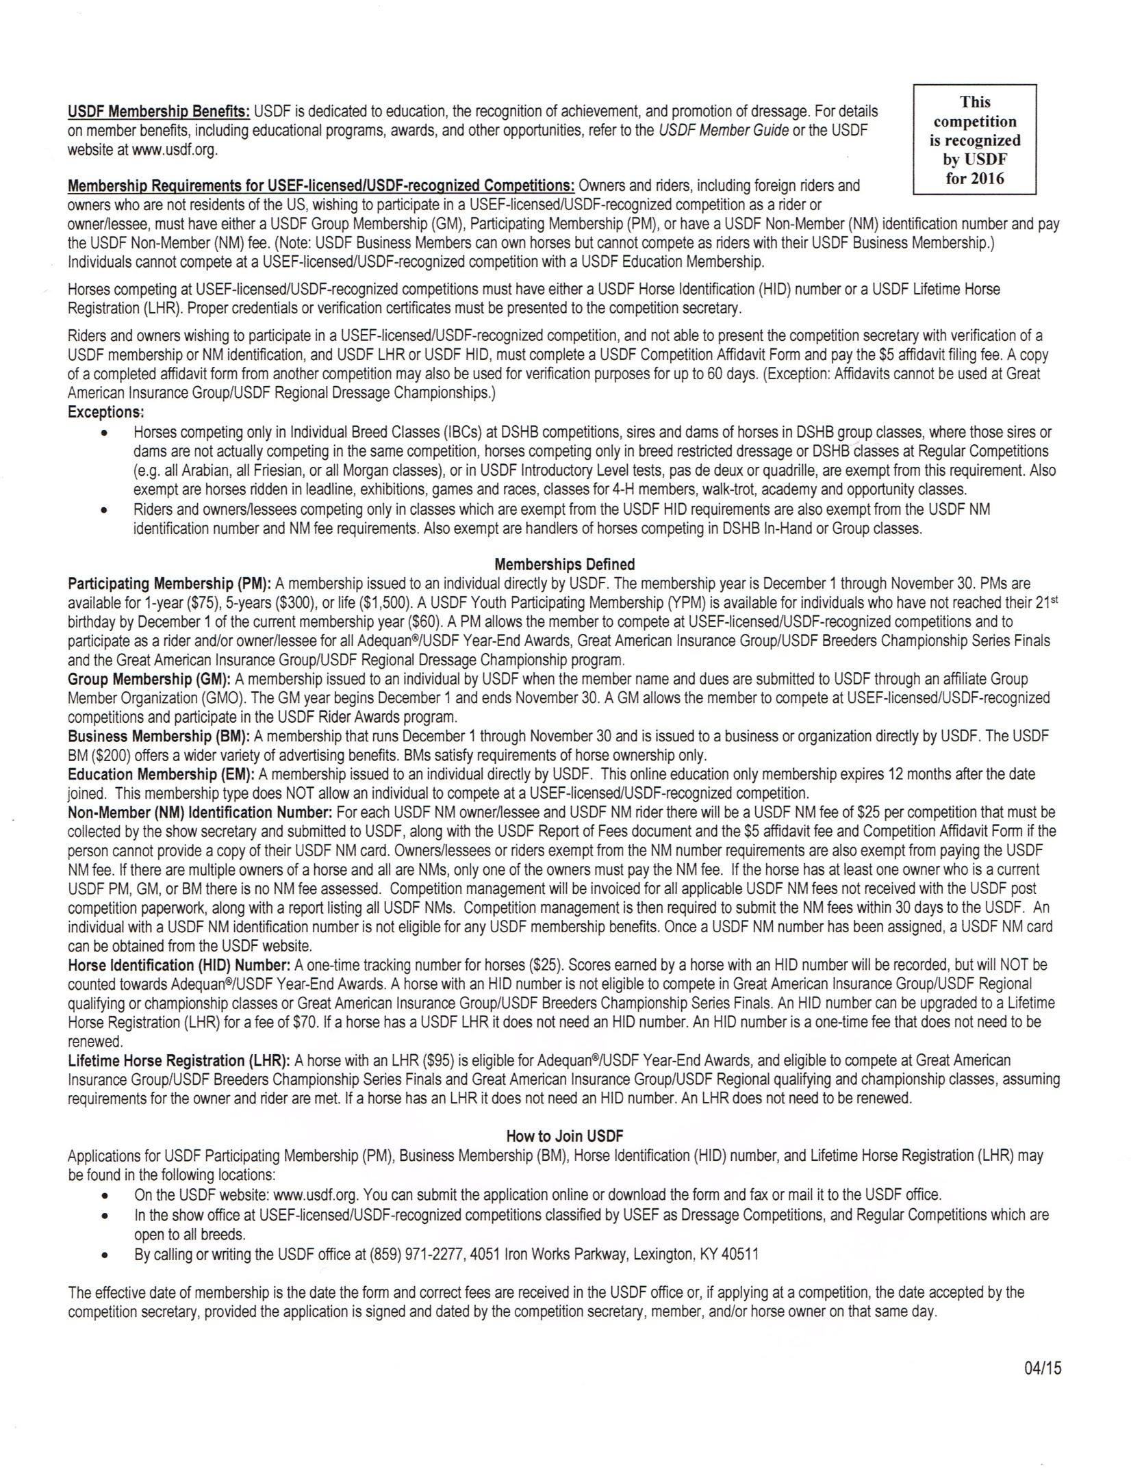
USDF Statement on Animal Welfare
The United States Dressage Federation, Inc. (USDF), a federation of over 100 independent organizations throughout the United States with a membership of nearly 30,000 members, supports the concept of ethical treatment of animals.
Dressage is a classical method of training horses, based upon the horse’s natural responses, as carried out in a gradual, planned program during which the horse’s athletic abilities are improved in a systematic manner. As a result, the horse becomes capable, comfortable, and responsive in partnership with the rider without the use of force. Dressage competition at various levels of achievement is the ultimate test of the training program to determine whether the desired harmony between horse and rider has been achieved.
The rules pertaining to dressage competition prohibit the use of artificial appliances, training aids, and drugs, which would force the horse to submit. Instead, the emphasis is upon training and a cooperative partnership with the rider. Major competitions are carefully monitored to assure that there is no unnecessary force or harshness displayed.
Unlike other horse sports in which horses enter training at a relatively immature state, dressage training is usually not seriously begun until the horse is three or four. The top levels of achievement require five or more years of progressive training and it is not unusual to see horses in international competition in their late teens. This, in itself, places a premium on good care and soundness throughout the horse’s life.
While supporting the concept of animal welfare in its broadest form, the United States Dressage Federation, Inc., also recognizes that it is unrealistic to ascribe human emotions and responses to the horse which in its wild state is a creature of flight, living a hard and precarious existence. Under domestication, the horse is assured of ample food, water, and shelter, as well as protection against infectious diseases and damaging parasites, thus leading a longer and healthier life with a high rate of survival.
As an educational organization, USDF has numerous programs, which teach people how to pursue the accepted, humane training methods. A program of certifying instructors also emphasizes protecting the horse’s welfare in pursuit of dressage training. United States Dressage Federation 4051 Iron Works Parkway, Lexington, KY 40511 Phone: 859-971-2277, Fax: 859-971-7722, usdressage@usdf.org

Motor Vehicle Statement
Minors who do not have a valid driver's license which allows them to operate a motorized vehicle in the state in which they reside will not be permitted to operate a motorized vehicle of any kind, including, but not limited to, golf carts, motorcycles, scooters, or farm utility vehicles, on the competition grounds of licensed competitions. Minors who have a valid temporary license may operate the above described motorized vehicles as long as they are accompanied by an adult with a valid driver's license. The parent(s), legal guardian(s), or individual who signs the entry blank as a parent or guardian of a minor operating a motorized vehicle in violation of this rule are solely responsible for any damages, claims, losses or actions resulting from that operation. Violations of this rule will be cause for sanctions against the parent(s), guardian(s) and/or trainer(s) who are responsible for the child committing the offense. Penalties may include exclusion of the child, parent(s), guardian(s), and/or trainer(s) from the competition grounds for the remainder of the competition and charges being filed against any of the above individuals in accordance with Chapter 6. Wheelchairs and other mobility assistance devices for individuals with disabilities are exempt from this rule

USEF MEMBERSHIP STATEMENT
Life, senior active and junior active members shall be eligible to participate in all classes at Regular Competitions, Eventing Competitions at the Preliminary Level or above and Combined Driving Competitions at the Advanced Level, Dressage, Reining and Vaulting Competitions and Endurance Rides. A nonmember may participate as a handler, rider,
driver, owner, lessee, agent, coach or trainer at Regular Competitions, Eventing Competitions, Dressage Competitions, Reining Competitions and Combined Driving Competitions upon payment of a $30 Show Pass fee. Participants in the following classes are exempted from the Requirements of this rule: 1) leadline; 2) exhibitions; 3) games and races; 4) classes for 4-H members; 5) walk trot and academy classes (academy classes are classes limited to horses used regularly in a lesson program); 6) USDF introductory level tests, pas de deux and quadrille classes;7) NRHA Endorsed Reining Competitions. 8) Opportunity classes, 9) citizens of other nations who have proof, in English, of current membership in good standing of their own National Federation, 10) USEA beginner novice division; and 11) assistant handlers in Dressage Sport Horse Breeding classes.

Additional Awards
Best Turned-Out Award
Presented each day of competition, registration required.
The Jockey Club T.I.P. High Point Thoroughbred Award
Will be awarded to the highest placing Thoroughbred in its division. TIP number must be provided.
2016 USDF/Dover Saddlery Adult Amateur Medal Program
Classes 223 & 23 – two opportunities to win!
The USDF/Dover Saddlery Adult Amateur Medal Program is designed to specifically recognize and encourage adult amateurs riding at Second Level. Awards
1. USDF/Dover Saddlery Medal Recipient The eligible rider with the highest score of 60 percent or better in the designated Second Level Test Three class or applicable test of choice USDF/Dover Saddlery Adult Amateur Medal class at a participating competition will receive a handcrafted USDF/Dover Saddlery pewter medal and neck ribbon. Winners will receive a $20 Dover Saddlery gift certificate for the first three USDF/Dover Saddlery Medals they win during the competition season.
2. USDF/Dover Saddlery National Merit Award A USDF/Dover Saddlery National Merit Award will be awarded to riders winning three USDF/Dover Saddlery Medals in the same competition year.
3. Year-End Awards The USDF/Dover Saddlery Medal National Champion and Reserve Champion are determined from the average of the top three winning ride scores during the competition year. The champion receives a $1000 Dover Saddlery gift certificate and the reserve champion receives a $500 Dover Saddlery gift certificate.
Rider Eligibility
1. Rider must have a current USDF Participating or Group Membership and be a member in good standing of USDF when the scores are earned.
2. Rider must be an adult amateur in accordance with Article GR1306 of the USEF rules and be designated with USEF as an adult amateur at the time the scores are earned.
Owner & Horse Eligibility
1. Horse and owner must meet minimum competition eligibility requirements at the time scores are earned.
Additional Information For additional information and an updated list of competitions offering the USDF/Dover Saddlery Adult Amateur Medal Program, please visit http://www.usdf.org/awards/performance/adultmedalprogram.asp.

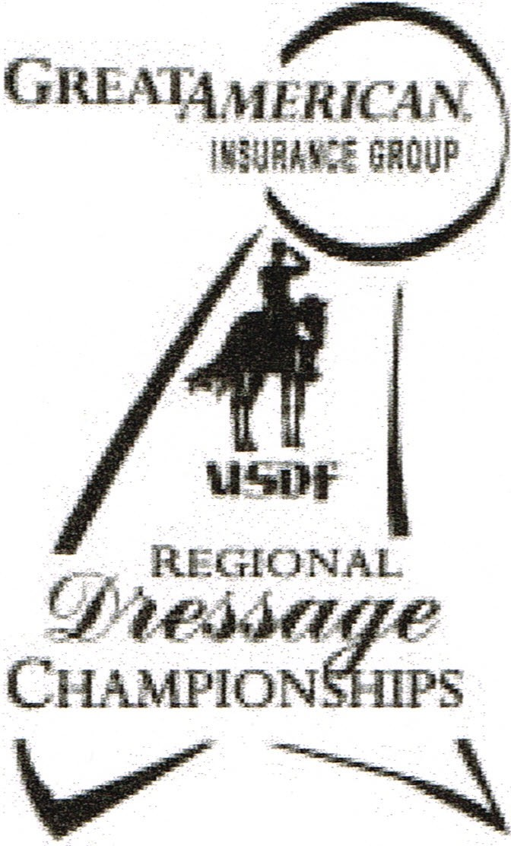
2017 Great American Insurance Group/USDF Regional Dressage Championships
A single Regional Dressage Championship program organized by the United States Dressage Federation (USDF), and recognized by the United States Equestrian Federation, Inc. (USEF), will be held in each of the nine USDF regions. In addition, Alaska and Hawaii may each hold state championships if an official request from a Group Member Organization (GMO) is received by April 1of the prior year. The Regional Championship Program Rules can be found on the USDF website at www .usdf.org. Please refer to the 2017 USDF Member Guide for the comprehensive list of rules and requirements for this program.

Membership/Registration Requirements for Qualifying and Championships
Rider:
- Must have a USDF Participating* Membership (PM) at the time qualifying scores are earned and at the time of the championships.
- Must have a USEF membership (Junior Active, Senior Active, or Life) at the time the qualifying scores are earned and at the time of the championships .
Horse:
- Must have a USDF Lifetime Horse Registration (LHR) at the time qualifying scores are earned and at the time of the championships.
- Must have a USEF (Annual or Lifetime) Membership recorded at the time qualifying scores are earned and at the time of the championships.
- USDF horse registration and USEF horse recording must be in the name(s) of the current owner(s) or lessee(s) of record.
- A horse is not required to have breed registry papers. Owner:
- Must have a USDF membership (PM* or Business Membership (BM)) at the time the qualifying scores are earned and at the time of the championships .
- Must have a USEF membership (Junior Active, Senior Active, or Life) at the time qualifying scores are earned and at the time of the championships.
* PMs are USDF members who join USDF directly . USDF Group Members (GM) are ineligible.

Minimum Qualifying Scores: One set of nationally-standardized qualifying scores has been established for all USEF/USDF Regional Championships, for Training Level through Grand Prix, in three divisions: open, adult amateur and junior/young rider. FEI Junior and FEI Young Rider classes have only one respective division. Freestyles have only open divisions.

The minimum percentages are as follows : | OPEN | AA | JRLYR
Training Level (Test 3) | 68% | 63% | 63%
First Level (Test 3) | 66% | 62% | 62%
Second Level (Test 3) | 64% | 61% | 61%
Third Level (Test 3) | 62% | 60% | 60%
Fourth Level (Test 3) | 62% | 60% | 60%
FEI Junior (Team Test) |  |  | 60%
FEI Young Rider (Team Test) |  |  | 60%
Prix St. Georges | 60% | 60% | 60%
Intermediate I | 60% | 60% | 60%
Intermediate II | 60% | 60% | 60%
Grand Prix | 60% | 60% | 60%
FREESTYLE | OPEN | AA | JRLYR
First Level | 63%
Second Level | 63%
Third Level | 63%
Fourth Level | 63%
Intermediate I | 63%
Grand Prix | 63% |  |  | Rev Feb 2016
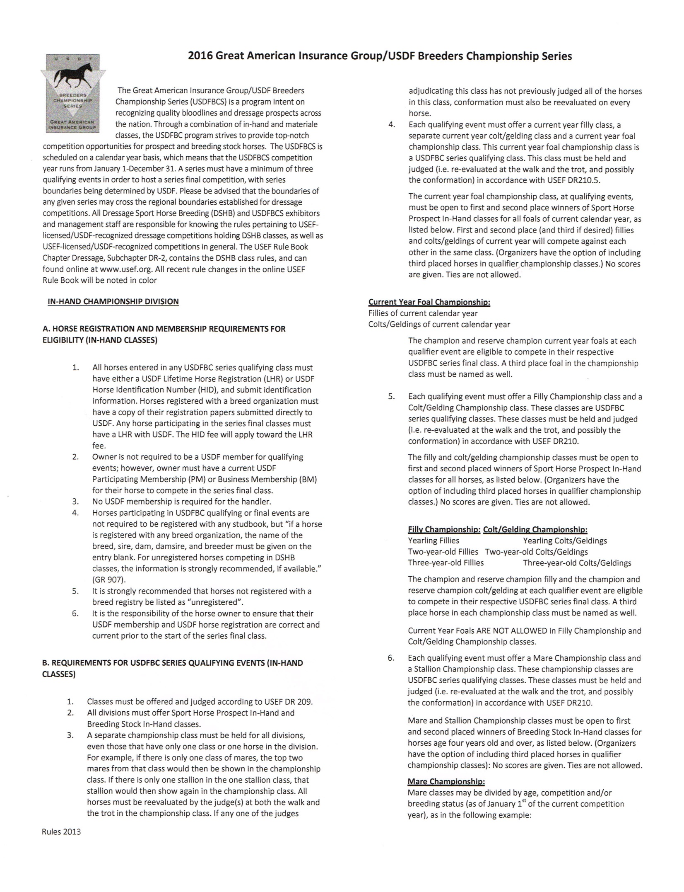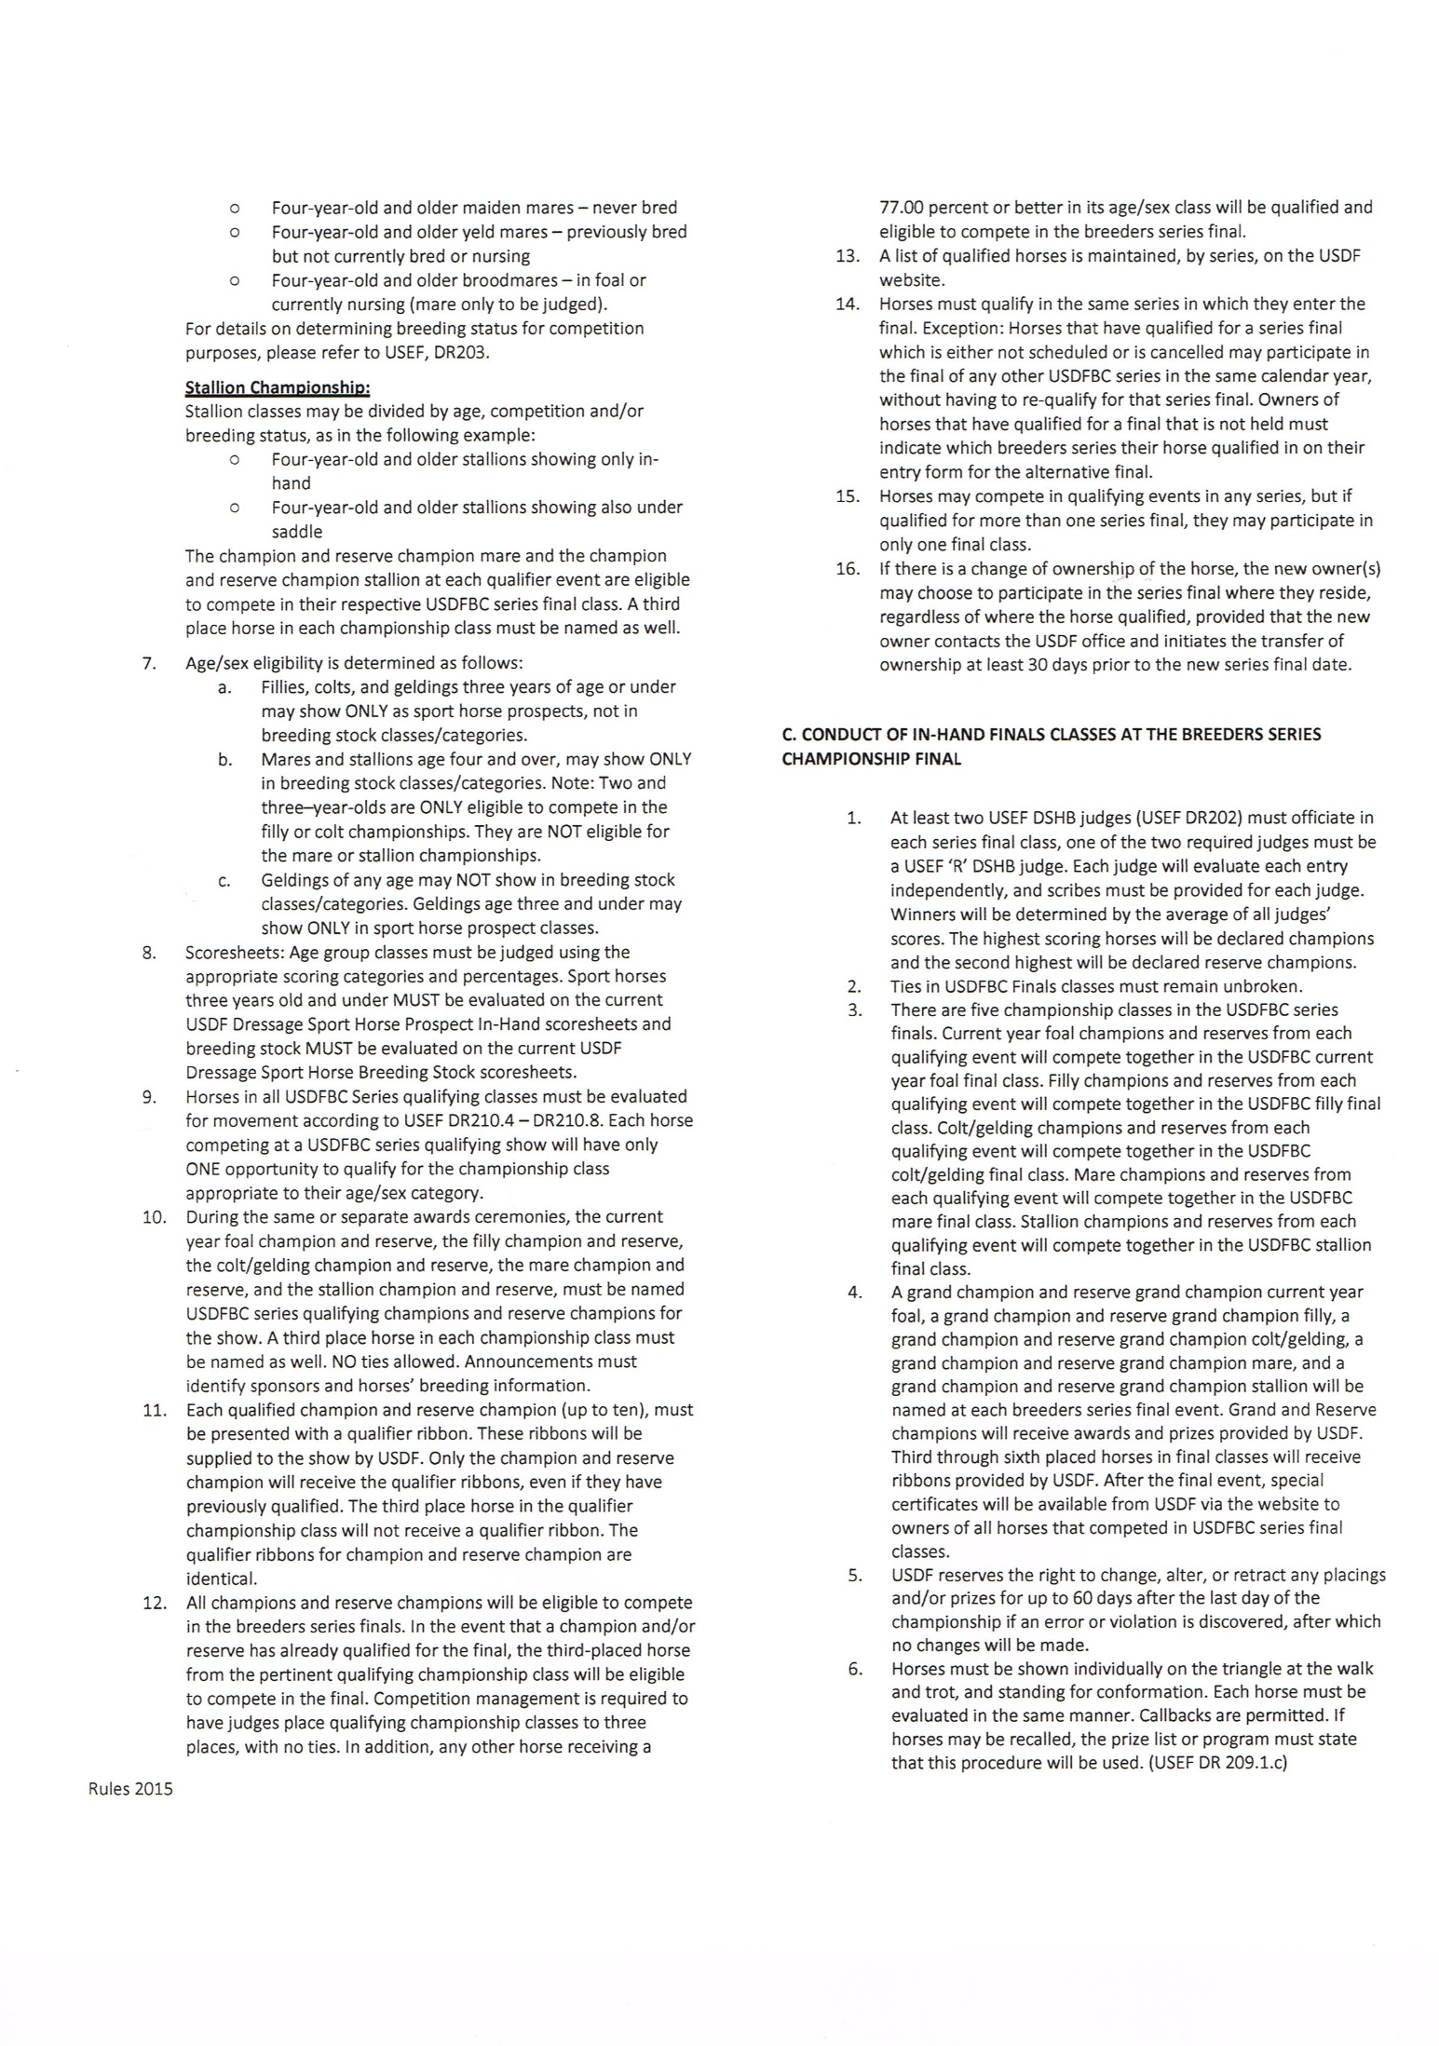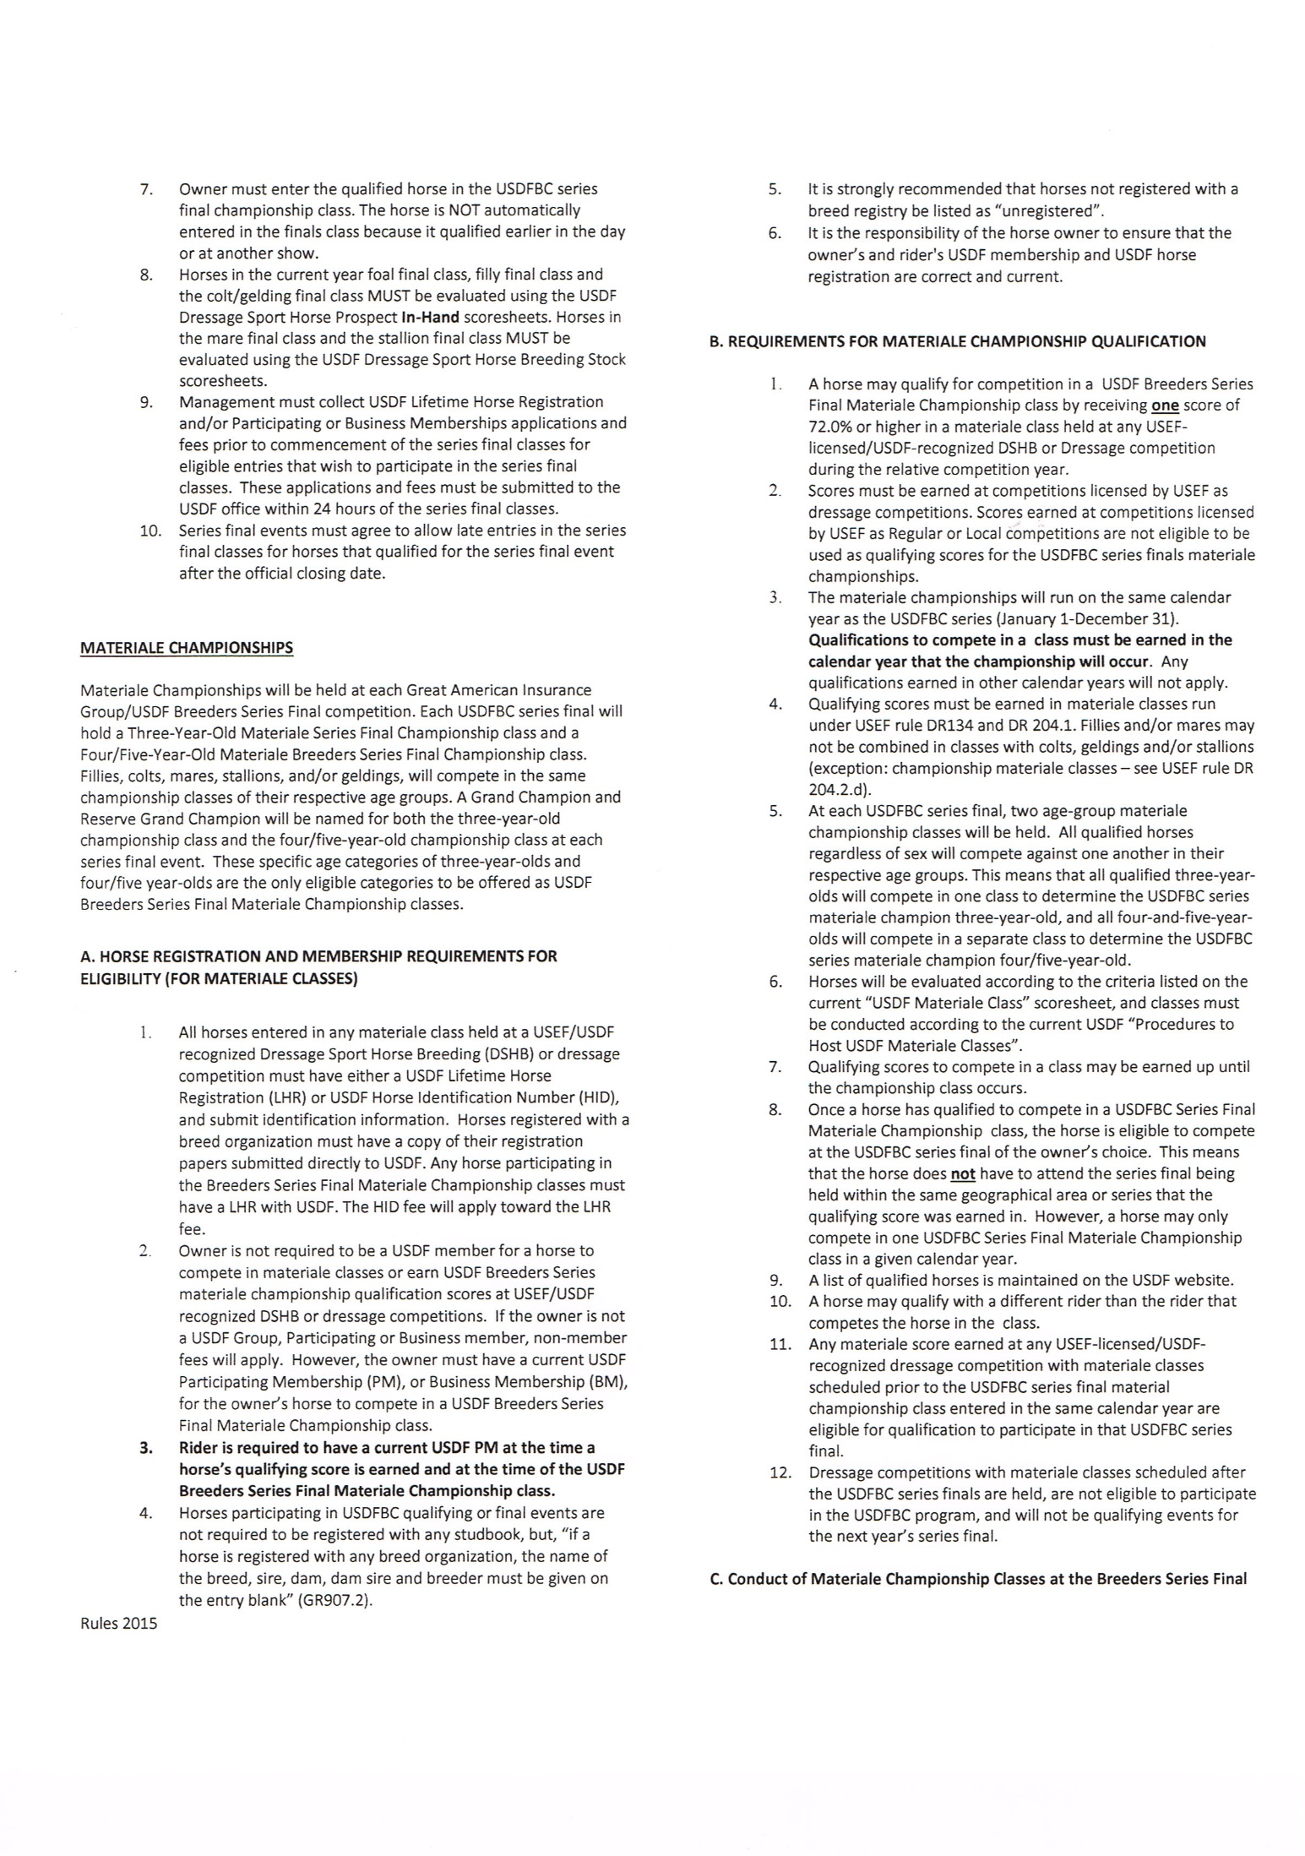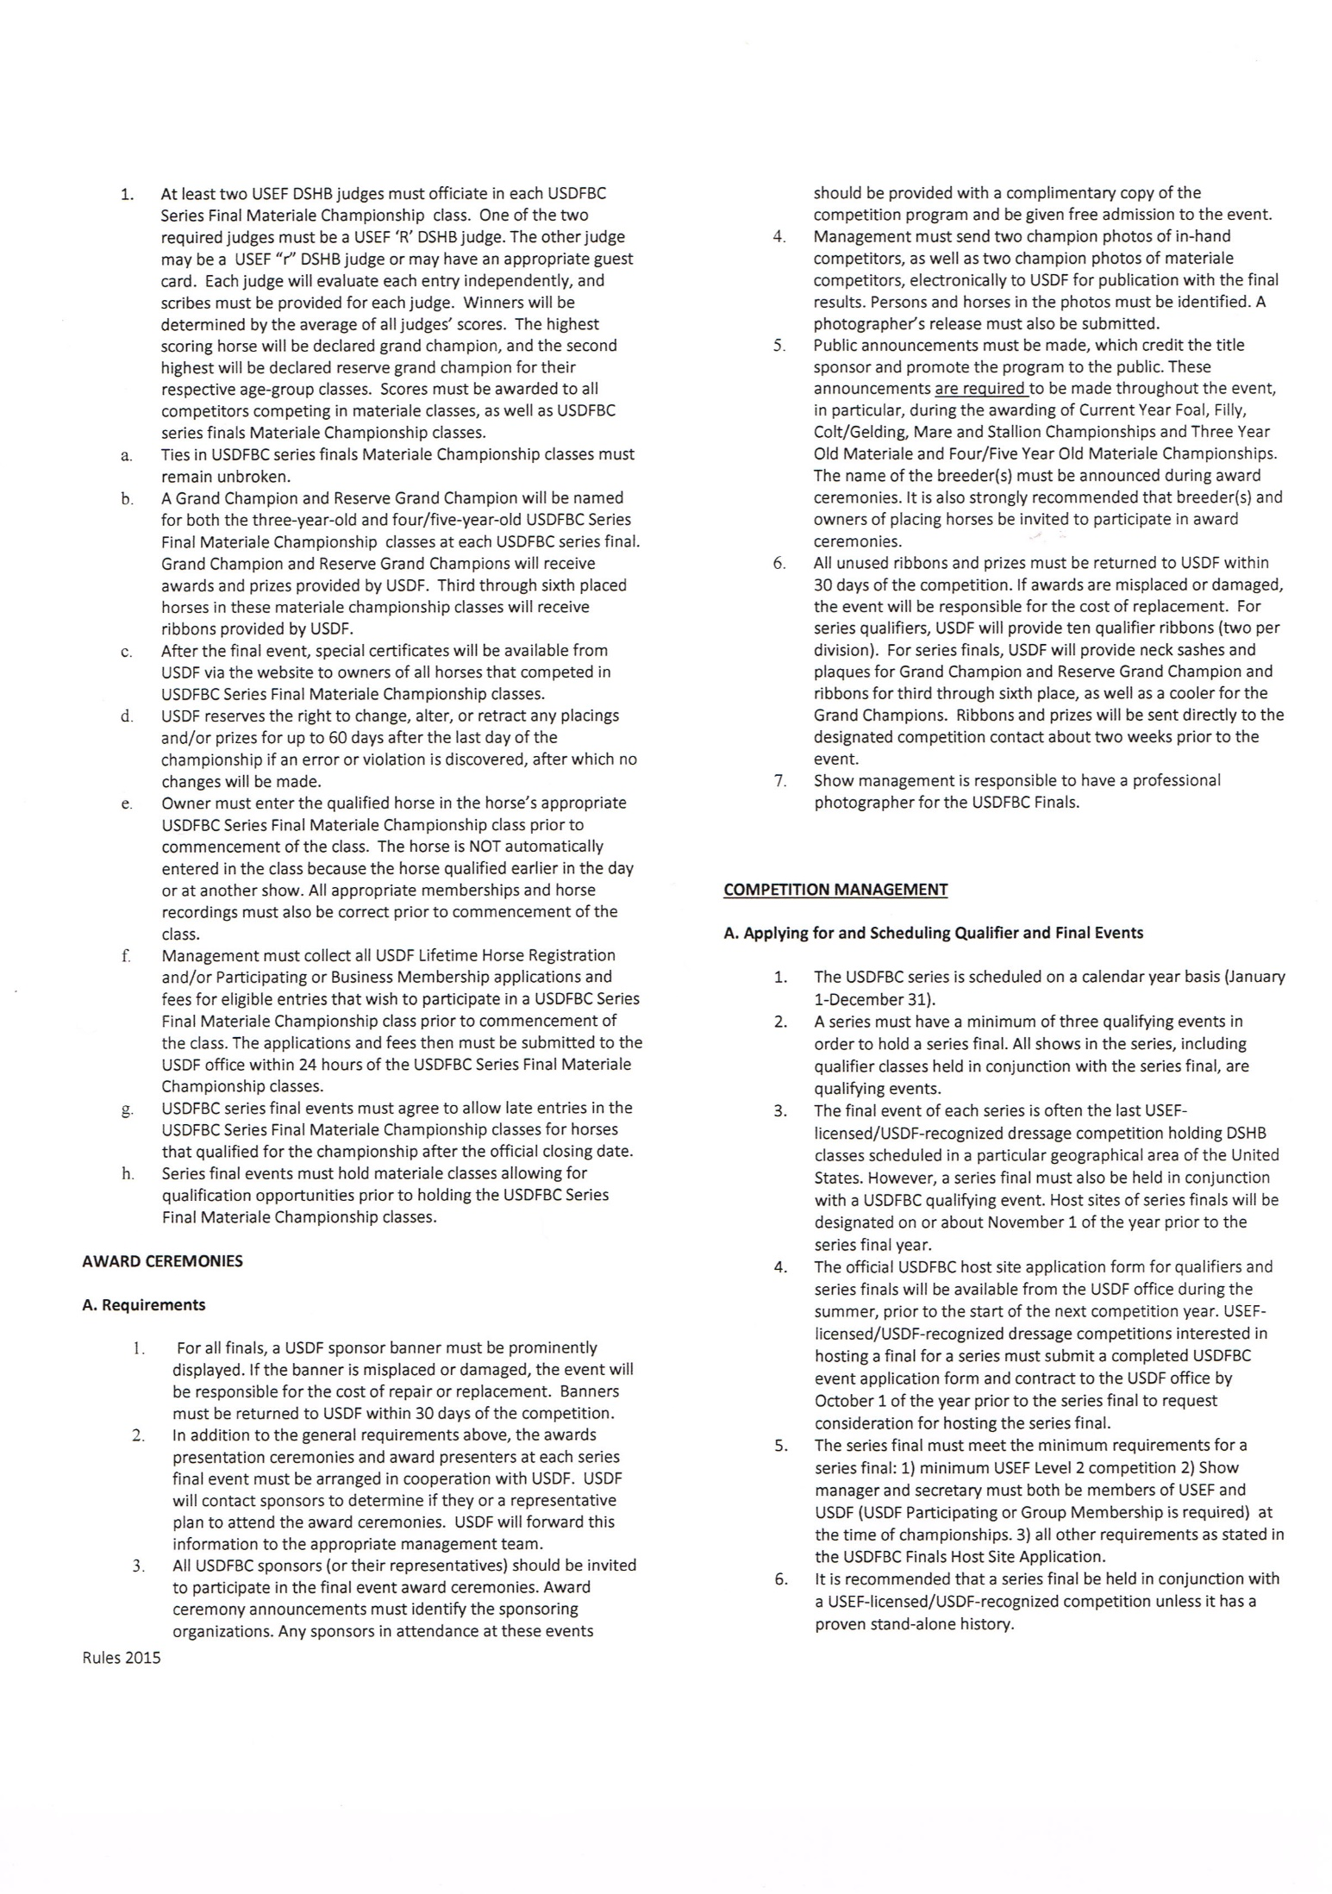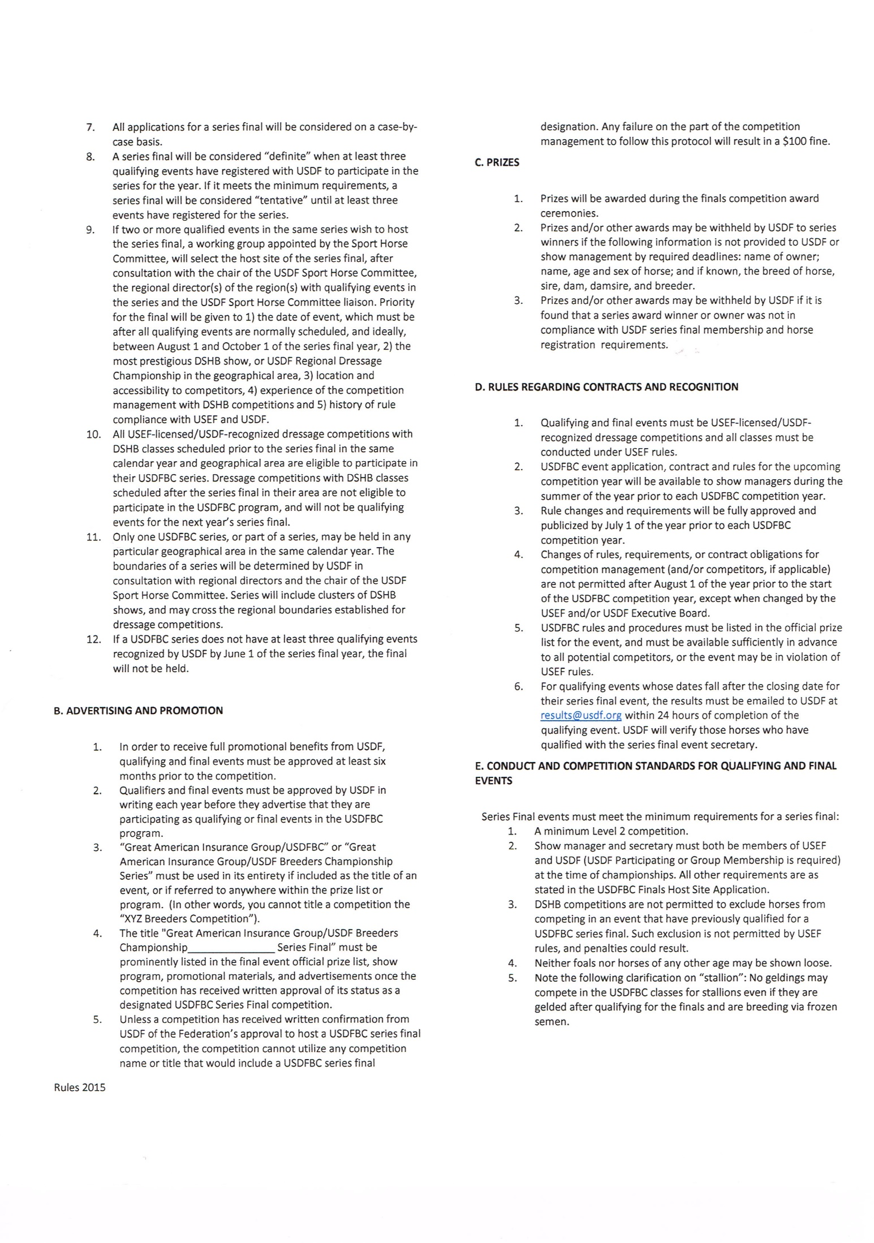
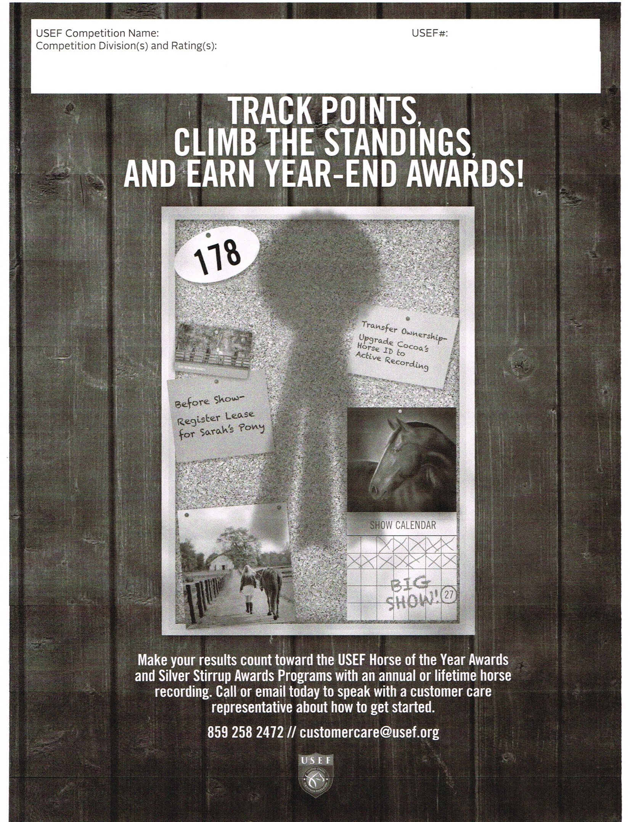
Dressage at Stone Tavern 315027, 329354
USDF Training Level – Grand Prix, FEI tests Level 3(329354) &2 (315027) Competition& Breed Show

