SALLY COUSINS INDOOR WINTER CLINICS AT THE HORSE
PARK OF NEW JERSEY! Jan 21, Feb 11, March 18!
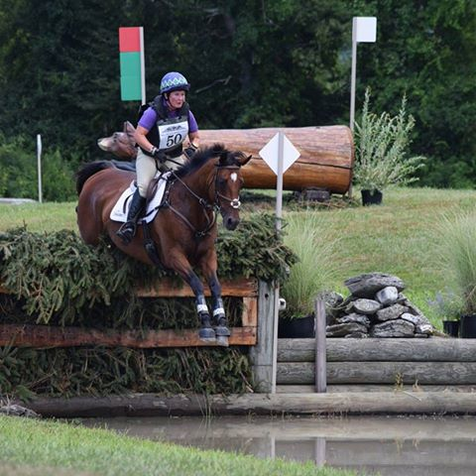
Sally was named USEA Leading Lady Rider of the Year 2008-2013! Even better, she is an active instructor, coach, trainer, competitor, dealing with all levels of horses and riders!
Fees: One clinic: $125; 2 clinics: $220.; ALL 3 clinics: $300!!! Must sign up for the series at one time, but can pay in installments 😊Details upon request .
January: Gymnastics; February: Course development; March: Hopefully outside in Grand Prix ring with xc fences and show jumps. Great preparation for the season!

To benefit Jersey Fresh International 2018!!!

Sign up by emailing jane@pleasanthollow.com, include name, address, level of horse,cell number, and any pertinent information to help assign to appropriate group.

Send check and coggins to Horse Park of New Jersey, 626 CR 524, Allentown, NJ 08501 att: Sally Cousins Clinic
Once your entry is accepted, you will receive more information and release. Check and coggins must be received to complete entry.

Snacks and water available during the day.

Spectators welcome, no charge!

