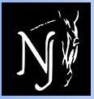
Dressage at the Park
626 Route 524, Allentown, NJ 08501

July 6&7, USEF/USDF #286066 – Level #3

2019 Col. Bengt Ljungquist Memorial Championship (BLM) Qualifying Competition
2019 Great American Insurance Group/USDF Qualifying Competition 2019 USDF Breeders’ Championship Series

SHOW DATES OPENING DATE CLOSING DATE

July 6 – 7, 2019 May 21, 2019 June 18, 2019

MANAGERS: SECRETARY:
Jennifer Bateman Debra McCluskey
215-804-6432 (email or text preferred) 609-203-6142
Jennifer@LittlePaddocksFarm.com DebraLMcCluskey@yahoo.com Jane Cory
215-262-2870 ONLINE ENTRIES ONLY:

EQUESTRIANENTRIES.COM
SHOW MANAGEMENT:
Horse Park of NJ
www.horseparkofnewjersey.com VET:
Foundation Equine – on call
SHOW COMMITTEE: 609-291-0535

Lynn Mathews
Debra McCluskey FARRIER:

Jennifer Bateman Tom Picinich – on call
732-685-1509
SHOW OFFICE PHONE:
215-804-6432(show days only) EMT SERVICES:

New Egypt Ambulance
STABLE MANAGER:
TBA TD: Camille Kopcik, R, NY

DAP JUDGES: Marilyn Payne, S, NJ

Ulf Wadeborn, S, CA, Susan Graham-White, R, MD
Breed Show Judge: Susan Graham-White, R, MD

DRESSGAE AT THE PARK CLASS LIST
Every class offered herein which is covered by the rules and specifications of the current USEF Rule Book will be conducted and judged in accordance therewith. USEF tests, Current editions.

Saturday, July 6th | Sunday, July 7th
USEF Tests, current editions | USEF Tests, current editions
101 Training Level Test 1-Open | 201 Training Level Test 1-Open
102 Training Level Test 2-Open /BLM | 202 Training Level Test 2-Open/BLM
103 Training Level Test 3-O/GAIG | 203 Training Level Test 3-O/GAIG
111 First Level Test 1-Open | 211 First Level Test 1-Open
112 First Level Test 2-Open/BLM | 212 First Level Test 2- Open/BLM
113 First Level Test 3- O/GAIG | 213 First Level Test 3- O/GAIG
121 Second Level Test 1-Open | 221 Second Level Test 1- Open
122 Second Level Test 2-Open/BLM | 222 Second Level Test 2-Open/BLM
123 Second Level Test 3- O/GAIG | 223 Second Level Test 3-O/GAIG
131 Third Level Test 1-Open | 231 Third Level Test 1-Open
132 Third Level Test 2-Open/BLM | 232 Third Level Test 2-Open/BLM
133 Third Level Test 3-Open/GAIG | 233 Third Level Test 3-O/GAIG
141 Fourth Level Test 1-Open | 241 Fourth Level Test 1-Open
142 Fourth Level Test 2-Open/BLM | 242 Fourth Level Test 2-Open/BLM
143 Fourth Level Test 3 – O/GAIG | 243 Fourth Level Test 3 O/GAIG
150 FEI PSG-Open/BLM/GAIG | 250 FEI PSG-Open/BLM/GAIG
151 FEI Intermed I-Open/BLM/GAIG | 251 FEI I- I-O/BLM/GAIG
152 FEI Intermed II-Open/BLM/GAIG | 252 FEI I - II-Open/BLM/GAIG
153 FEI Gr Prix Test-Open/BLM/GAIG | 253 FEI GP Test-O/BLM/GAIG
154 FEI Test for 5 year olds – O | 254 FEI Test for 5 year olds – O
154.1FEI Test for 6 year olds – O | 254.1 FEI Test for 6 year olds – O
155 FEI YR Team Test - O/GAIG | 255 FEI YR Ind. Test – O/ GAIG
156 FEI JR Team Test – O/GAIG | 256 FEI JR Individual Test –O /GAIG
157 FEI TOC+ - Open | 257 FEI TOC+ - Open
158 Para Equestrian- TOC + - Open | 258 Para Equestrian- TOC + - Open
159 USEF 4 yr old test – Open/ GAIG | 259 USEF 4 yr old test – Open/ GAIG
160 USDF MFS- Open/(1st-4th)BLM/GAIG | 260 USDF MFS-O/(1st-4th)BLM/GAIG
161 USDF Pas de Deux+ | 261 USDF Pas De Deux+ - Open
170 FEI MFS-O/BLM/GAIG+ | 270 FEI MFS-O/BLM/GAIG+
171 FEI Pony Team Test – O/GAIG | 271 FEI YR Freestyle – Open
171.1FEI Pony Individual Test – O/GAIG | 271.1 FEI JR Freestyle – Open
172 USEF Brentina’s Cup Test – Open | 272 FEI Grand Prix 16-25 Test O/GAIG
173 USEF Dressage Seat Equitation – Open/GAIG | 273 Dressage Seat Equitation – O/GAIG
174 USEF Developing Horse PSG – O/ GAIG | 274 Developing Horse PSG – O/ GAIG
175 USEF Developing Horse Grand Prix – O/ GAIG  200 USDF Introductory Level TOC+ | 275 Developing Horse Grand Prix – O/ GAIG  300 USDF Introductory Level TOC+
+ Please specify test of choice. TOC must be test not be offered.
Opportunity Classes offered*
101.1 Opportunity Training Level Test 1(Sat) 201.1 Opportunity Training Level Test 1 (Sun)
103.3 Opportunity Training Level Test 3(Sat) 203.3 Opportunity Training Level Test 3 (Sun)
Please state on entry whether riding Open, BLM, or GAIG/USDF Qualifying and status of Amateur, Open, or JR. Management reserves the right to split, cancel, or combine classes. GAIG classes are 2019: If entering as Great American/USDF Qualifying, please indicate on your entry form your rider status and include the $15 Qualifying fee. Classes 157 and 257 cannot be ridden as GAIG/USDF Qualifiers.

Dressage at the Park Breeding Show Class List USDFBC 2019 Series
Susan Graham White, R officiating
For all age-specific classes, horse proof of age (breed registration certificate or vet certificate showing foal date) MUST be provided with entry form.

Young Horse/Dressage Sport Horse Prospect: To be shown in-hand at the walk and trot on the triangle. Halters mandatory on foals. Bridles optional on yearlings, but mandatory on all horses 2 years or older. Mares accompanying foals must wear a bridle and must be issued a separate bridle number.

Every class offered herein which is covered by the rules and specifications of the current USEF Rule Book will be conducted and judged in accordance therewith.

Saturday, July 6th
401 | Fillies of 2019 – with or without dam; only foal judged
402 | Filly Yearlings
403 | Filly 2 Year Olds
404 | Filly 3 Year Olds
405 | Filly Championship* (1st&2nd place from 402-404 to be judged)
406 | Colt/Geldings of 2019 with or without dam; only foal judged
407 | Colt/Gelding Yearlings
408 | Colt/Gelding 2 Year Olds
409 | Colt/Gelding 3 Year Olds
410 | Colt/Gelding Championship* (1st&2nd place from 407-409 to be judged)
411 | Foals of 2019 Championship* (1st&2nd place from 401 and 406 to be  judged)
412 | Young Horse Championship: Champion and Reserve from classed  405 and 410 to be judged

Mature Horse/Dressage Breeding Stock: To be shown in-hand at the walk and trot on the triangle. To be scored 50% movement, 40% conformation, and 10% general impression. Bridles are mandatory.

413 | Broodmares – with or without foals; 4 years old or older; only mares judged
414 | Mares – maiden or yeld; 4 years old or older
415 | Mare Championship* - 1st&2nd place from 413 & 414 to be judged
416  417 | Stallions – Shown in-hand or under saddle at this show. Four years old and older  Stallion Championship*- 1st & 2nd place from class 416 to be judged.
419 | Mature Horse Championship- Champion and Reserve from classes 415 and  417 to be judged.*
420 | Grand Championship – Champion and Reserve from classes 412 and 419 to  be judged.*
- No fee. Champion & Reserve qualify for USDFBC East Coast Series Final.

Individual Breed Classes: All IBC Classes to be shown in-hand at the walk and trot on the triangle. To be scored 60% movement, 30% conformation, 10% general impression. MUST include copy of breed papers or verification of breeding to participate in ANY IBC class and any breed-specific membership cards.
427 | HANOVERIAN – Open to any American Hanoverian Society-registered horse of  any age and sex whose owner is current AHS member.
428 | CLEVELAND BAY – Send breed registration papers.
429 | OLDENBURG/ISR – Send breed registration papers.
430 | OLDENBURG/GOV – Horse must be registered with Horse OHBS/GOV. Send
 | breed registration papers for eligibility.
431 | SWEEDISH WARMBLOOD - Send breed registration papers
432 | DUTCH WARMBLOOD (KWPN OR NAWPN) – Send breed registration papers.
433 | FRIESIAN - Send breed registration papers.
434 | ARABIAN/HALF-ARABIAN – Horse must have AHA papers (or eligibility) for
 | purebred, half Arabian, or Anglo Arab. Send breed registration papers.
435 | ANDALUSIAN/LUSITANO – Open to any pure or partbred Andalusian or Lusitano,
 | all ages. Send breed registration papers.
436 | RHEINLAND PFALZ-SAAR INTERNATIONAL (RPSI) - The foal/horse shall be entered
 | into the German Breeding Books. Send breed registration papers.
437 | BELGIAN WARMBLOOD (BWP) - Send breed registration papers.
438 | IRISH DRAUGHT HORSE - Open to any age or gender horse registered or
 | recorded as Irish Draught or Irish Draught Sport Horses with IDHSNA. Owners
 | must be members in good standing. Send breed registration papers.

Under Saddle Classes: To be shown at the walk, trot, and canter, both ways of the ring. Horses entered in the following classes are not required to have shown in any in-hand or group classes. Classes 322 – 324 to be scored 60% movement, 30% conformation, and 10% general impression (including balance, impulsion, and rideability). 325 – 326 to be scored 30% Walk, 30% Trot, 30% Canter, and 10% General Impression.
425 Materiale for 3, 4, and 5 year old Fillies/Mares (Class may be split by horse age if entries warrant)
426 Materiale for 3, 4, and 5 year old Colts/Geldings/Stallions (Class may be split by horse age if entries warrant)
Riders/Handlers MUST provide emergency contact information on their entry form. Assistant handlers must sign separate release to participate in show. USDF Horse ID # required for all entries in the Breed Show except horses that are ONLY competing in IBC classes.

Entry Fees – make check payable to Horse Park of NJ in US currently ONLY

REQUIRED FEES-All entries should include these fees

Class Fees:
Training thru Fourth Level | $40
FEI Level Classes | $50
USDF Musical Freestyles | $50
FEI Musical Freestyles; Pas de Deux | $55
Dressage Seat Equitation | $35
Breed Show Individual Class | $40
Breed Show Under Saddle Class | $40
Introductory Level Classes | $35
Federation Fee: ($15 drug fee & $8 USEF fee) | $23/horse
Office Fee (Non-Refundable) | $30/entry
Additional Fees:
GAIG/USDF Qualifying – additional per class | $15/class
USEF Show Pass (Rider/Owner/Trainer) | $45
USDF Non-Member Fee | $35
USDF Horse ID | $35
Secretary Verification of Documents (ONLY applied if entry is incomplete) $10
Class Change, if granted by show secretary $10 per change
Non-competing Horse Fee (includes office fee) $40

Post Entry Surcharge: $30
(Applies to all entries RECEIVED after the closing date)
Stabling/Tack Stall for entire weekend (arrive Fri depart Sun) $135 Stabling/Tack Stall - day stall (must depart by 8 pm) $50
Shavings pre-ordered $8/bag
Shavings on-site $9/bag
Haul-in Fee (non-stabled horses) $15/day
Camper hook-up $45

ENTRIES: Online entries only through EquestrianEntries.com. Payment in US currency only. Entries must be received by the closing date or $30 late fee is applied. Illegible or incomplete entries may be returned. All entries must be typed or printed on an official USEF/USDF entry form and include: original handwritten signatures (owner, rider, trainer and coach, if applicable), photo- copy of negative Coggins test dated within 12 months of show date, proof of vaccination per GR 845, and copies of USEF and USDF membership or identification cards for each owner, rider, trainer, and horse, as applicable. Emergency number must be included. A $10 fee will be assessed for secretary printing missing or incorrect information. No refunds after closing date or for “acts of god” which require management to cancel classes or day(s) of competition.
TIMES: Times will be on the website www.horseparkofnewjersey.com and at http://www.foxvillage.com. Official times will available at noon the day before the show. All change requests must be made in writing by 4:00PM the Thursday prior to the show. All no-shows will be scratched from their subsequent tests.
AWARDS: (ONLY tests will be mailed post competition) Award and ribbons 1-6 awarded each division (min 3 entries)
Champion award and Reserve Champion ribbon per level. Level Champion and Reserve winners will be awarded at specific times in the Winners Circle (mounted preferred). Several breed specific awards, see page 10 for details.

HAZARDOUS WEATHER/ACT OF GOD/ ACCIDENT POLICY: Management reserves the right to cancel any classes due to hazardous weather, Acts of God, accident or emergency. Every effort will be made to reschedule with priority given to

any qualifying classes being offered. No refunds for cancellations due to hazardous weather, Acts of God, accidents or emergencies.

SCHEDULE: Classes may not necessarily run in the order listed in the prizelist. Current management tends to schedule upper level rides in the cooler morning times. It is the responsibility of the rider to inform the show secretary of any time conflicts as soon as possible after receiving the schedule. Management reserves the right to change officials, limit entries, combine or cancel classes, modify the schedule, modify or cancel awards and/or whatever changes are required by circumstances to the competition specifications.

SCORES: It is the responsibility of the competitor to verify the accuracy of all scores. Scoring errors must be reported to the Show Secretary within one hour of the official posting of the scores from the last class of the show day during which the score was earned.

STABLING: 10’ x 10’ temporary stalls, stall door provided. See the above fee schedule for information. Day stalls must be vacated by 8 pm same day of use; must purchase full weekend stabling to stable overnight. Please indicate stabling concerns on entry form.

FOOTING: Standard outdoor competition rings (sand/screenings mixture); indoor ring is sand. Separate ring for lunging.

FREESTYLES/MUSIC: Horse/rider combination must have received a minimum score of 63% in the highest test of the declared freestyle level or any test of a higher level at a Federation Licensed or FEI recognized Dressage Competition or “open” Dressage class (i.e. open to all breeds) at a Federation Licensed Competition held prior to this competition. A photocopy of the test verifying eligibility, or copy of the USDF score verification, must be submitted with the entry for a freestyle class. Music for all freestyles on CD must be given to show office upon check in. It is the responsibility of the competitor, if requested, to supply the management with a sound person to run the music. Sound checks will be done on breaks prior to scheduled times.

OPPORTUNITY CLASSES/INTRO TESTS: Opportunity classes are intended for entry level riders. Horses and riders
entered only in “Opportunity” classes and Introductory tests are exempt from USEF and USDF membership requirements, and do not have to pay non-members (Show Pass) or HID fees. Federation and drug fees do not apply. Horses entered only in these classes are still subject to and must comply with the Drugs and Medications rules and are subject to drug testing. Riders and/or horses entered in “Opportunity” classes may not cross enter into other recognized classes at the show without membership or payment of non-member fees. Participants must abide by all USEF regulations to attire, tack, and equipment for the recognized show. Reference GR821 for additional information.

ACCOMODATIONS: Hampton Inn 609-426-1600, ask for Special Horse Park of NJ rate. See horseparkofnewjersey.com for others.

PROFESSIONAL SERVICES: Contact numbers posted the day of the show in the secretary stand. An EMT/Med Tech will be on grounds. Vet and Farrier will be on call.

DIRECTIONS: 626 Route 524, Allentown, NJ 08501, Take I-195 to Exit 11, follow signs for Horse Park of NJ.

OTHER: Food available on grounds. Dogs MUST be leashed at all times.

ATTENTION COMPETITORS
Each competitor is responsible for supplying management with correct applicable numbers (USDF and USEF) for horse, owner, rider, and trainer before the day(s) of the competition. The scores of competitors who fail to supply correct numbers may not be counted toward national awards. Important Entry Information Requirements: Safe Sport Training must have been completed for USEF membership to be valid. All entries must include copies of all memberships for horse, owner, rider and trainer listed on entry form. SAFE SPORT TRAINING is required for all riders, owners and trainers within 30 days of membership. If Safe Sport Training has not been completed within 30 days of membership, entries will not be accepted until proof of completion is provided. If membership is renewed during show, Safe Sport Training must be completed within 30 days or results will be nullified. Senior members that are ineligible at the start of the show must complete Safe Sport and present their certificate prior to competing to be eligible to compete and for their points to count. The scores of competitors who fail to supply correct numbers may not be counted toward national awards.

IMPORTANT VACCINATION REQUIREMENTS
HPNJ in compliance with GR 845 will require proof of Equine Influenza Virus and Equine Herpes Virus vaccination for all horses entering the show grounds prior to unloading the horse.

If a competitor is a no-show for their first test of the competition they will be scratched from their remaining tests for the day.

Sharps Containers: Show management will provide one sharps container per 50 stabled horses, per USEF rule 1211.5. Competition Management may fine any individuals including trainers, owners, exhibitors, or their agents up to $100 for improper disposal of needles or other sharp disposable instruments.

USEF rules go into effect upon arrival at the show grounds. Per DR120.1-6 PROTECTIVE HEADGEAR MUST BE WORN AT ALL TIMES WHEN MOUNTED. Bridle numbers must be worn at all times when a horse is out of stall or trailer.

HOLD HARMLESS CLAUSE: Understanding that horse sports may be hazardous and dangerous, even leading to permanent injury or death, each owner, rider, spectator, and other participant assumes any and all risk of loss or injury and agrees to hold harmless, regardless of negligent acts or omissions The Horse Park of New Jersey, the show management, show committee, and all horse show personnel.
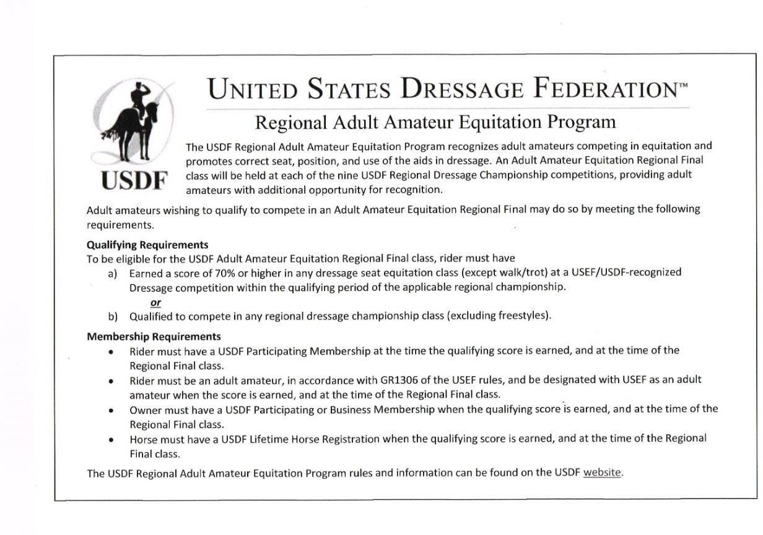
SHOW PASS FEE: Effective 12/1/2013, a non-member who wishes to participate in a USEF competition must pay a Show Pass fee in lieu of a USEF non-member fee. Please see GR 205 for additional information.

Award Ceremonies and Special Awards
Level Champions and Reserves will be awarded in the Winners Circle. Please plan to accept mounted. Times will be posted in the Day Sheets.

Best Turned-Out Award

Presented at end of competition, registration required.
Breed Specific Awards

Please submit breed papers with entry. Verification will be done with respective Associations prior to the show. Entries without verification will not be considered. Please visit specific registries for more information.
American Hanoverian Society High Point Awards

Performance Award presented to the highest scoring registered Hanoverian for the weekend.
Breed Award presented to the highest scoring registered Hanoverian at DAST I breed show. Owner must be AHS member. Send proof of membership and papers with entry.
ISR/Oldenburg High Point Award

Performance Award presented to the highest scoring International Sporthorse Registry or Oldenburg Registry North America horse for the weekend. GOV registered horses are not eligible.
KWPN of North America High Point Awards

Performance Award presented to the highest scoring registered KWPN with KWPN of NA.
Owner must be “owner of Record”.
Breed Award presented to the highest scoring registered KWPN with KWPN of NA. Owner must be “owner of Record”.

The Jockey Club T.I.P. High Point Thoroughbred Award

Will be awarded to the highest placing Thoroughbred in its division. TIP number must be provided.

Topline Champion Challenge
Over $1500 in prizes

The Topline Champion Challenge is a series of ten events at three different venues. Professional and Adult Amateur (Training level through FEI) awards offered. No fee in addition to Required Show Entry fees.

Professionals: Rider may compete multiple horses across the levels in 5 of 10 competitions to qualify. The six best scores of each professional rider will be averaged and the highest average percentage will be champion. Champion through 6th place awarded. Scratches will not count toward the average; if an
Elimination must be counted, it will be awarded a “score” of 50.000% towards the average.

Adult Amateur: Horse and rider combination must compete in 5 of 10 competitions over no more than two levels to qualify. The six best scores of each horse and rider combination will be averaged and the highest average percentage will be champion at each level. If a combination rides over two levels, they will qualify at the level in which they rode 60% of their tests. Scratches will not count toward the average; if an Elimination must be counted, it will be awarded a “score” of 50.000% towards the average.

SHOW | SHOW DATE(s) | VENUE
Dressage at Bucks County Horse Park I | May 4, 2019 | Bucks County Horse Park, Revere, PA
Good Times Farm Dressage Show | June 1, 2019 | Good Times Farm, Freehold, NJ
Dressage at Bucks County Horse Park II | June 2, 2019 | Bucks County Horse Park, Revere, PA
Dressage at Bucks County Horse Park III | June 30, 2019 | Bucks County Horse Park, Revere, PA
Dressage at the Park | July 6 & 7, 2019 | Horse Park of NJ, Allentown, NJ
Dressage at Bucks County Horse Park IV | August 4, 2019 | Bucks County Horse Park, Revere, PA
Good Times Farm Dressage Show II | August 17, 2019 | Good Times Farm, Freehold, NJ
Dressage at Stone Tavern I | Sept. 6 & 7, 2019 | Horse Park of NJ, Allentown, NJ
Dressage at Stone Tavern II | Sept. 8, 2019 | Horse Park of NJ, Allentown, NJ
Good Times Farm Dressage Show III | Sept. 14, 2019 | Good Times Farm, Freehold, NJ

SERIES MANAGEMENT:
Bucks County Horse Park: Jennifer Bateman, Jennifer@BucksCountyHorsePark.org Good Times Farm: Debra McCluskey, DebraLMcCluskey@yahoo.com
Horse Park of New Jersey: Jennifer Bateman, Jennifer@BucksCountyHorsePark.org

CHALLENGE ENTRY FORM – Can be found on all websites. Form is required to participate, must be submitted no later than September 1, 2019.

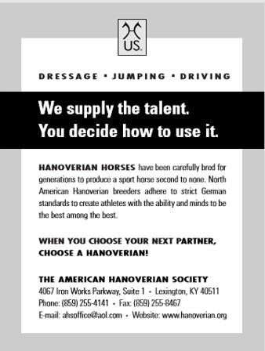
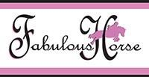
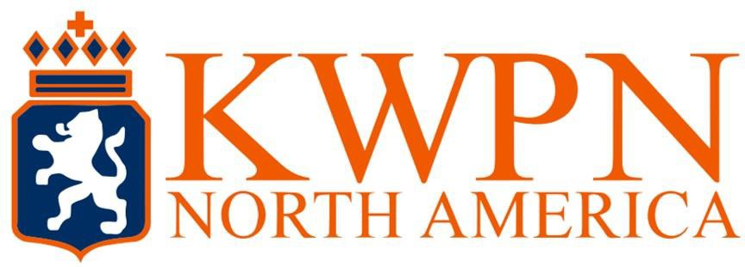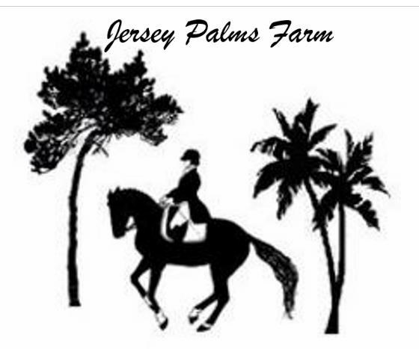Thank you to our wonderful sponsors!

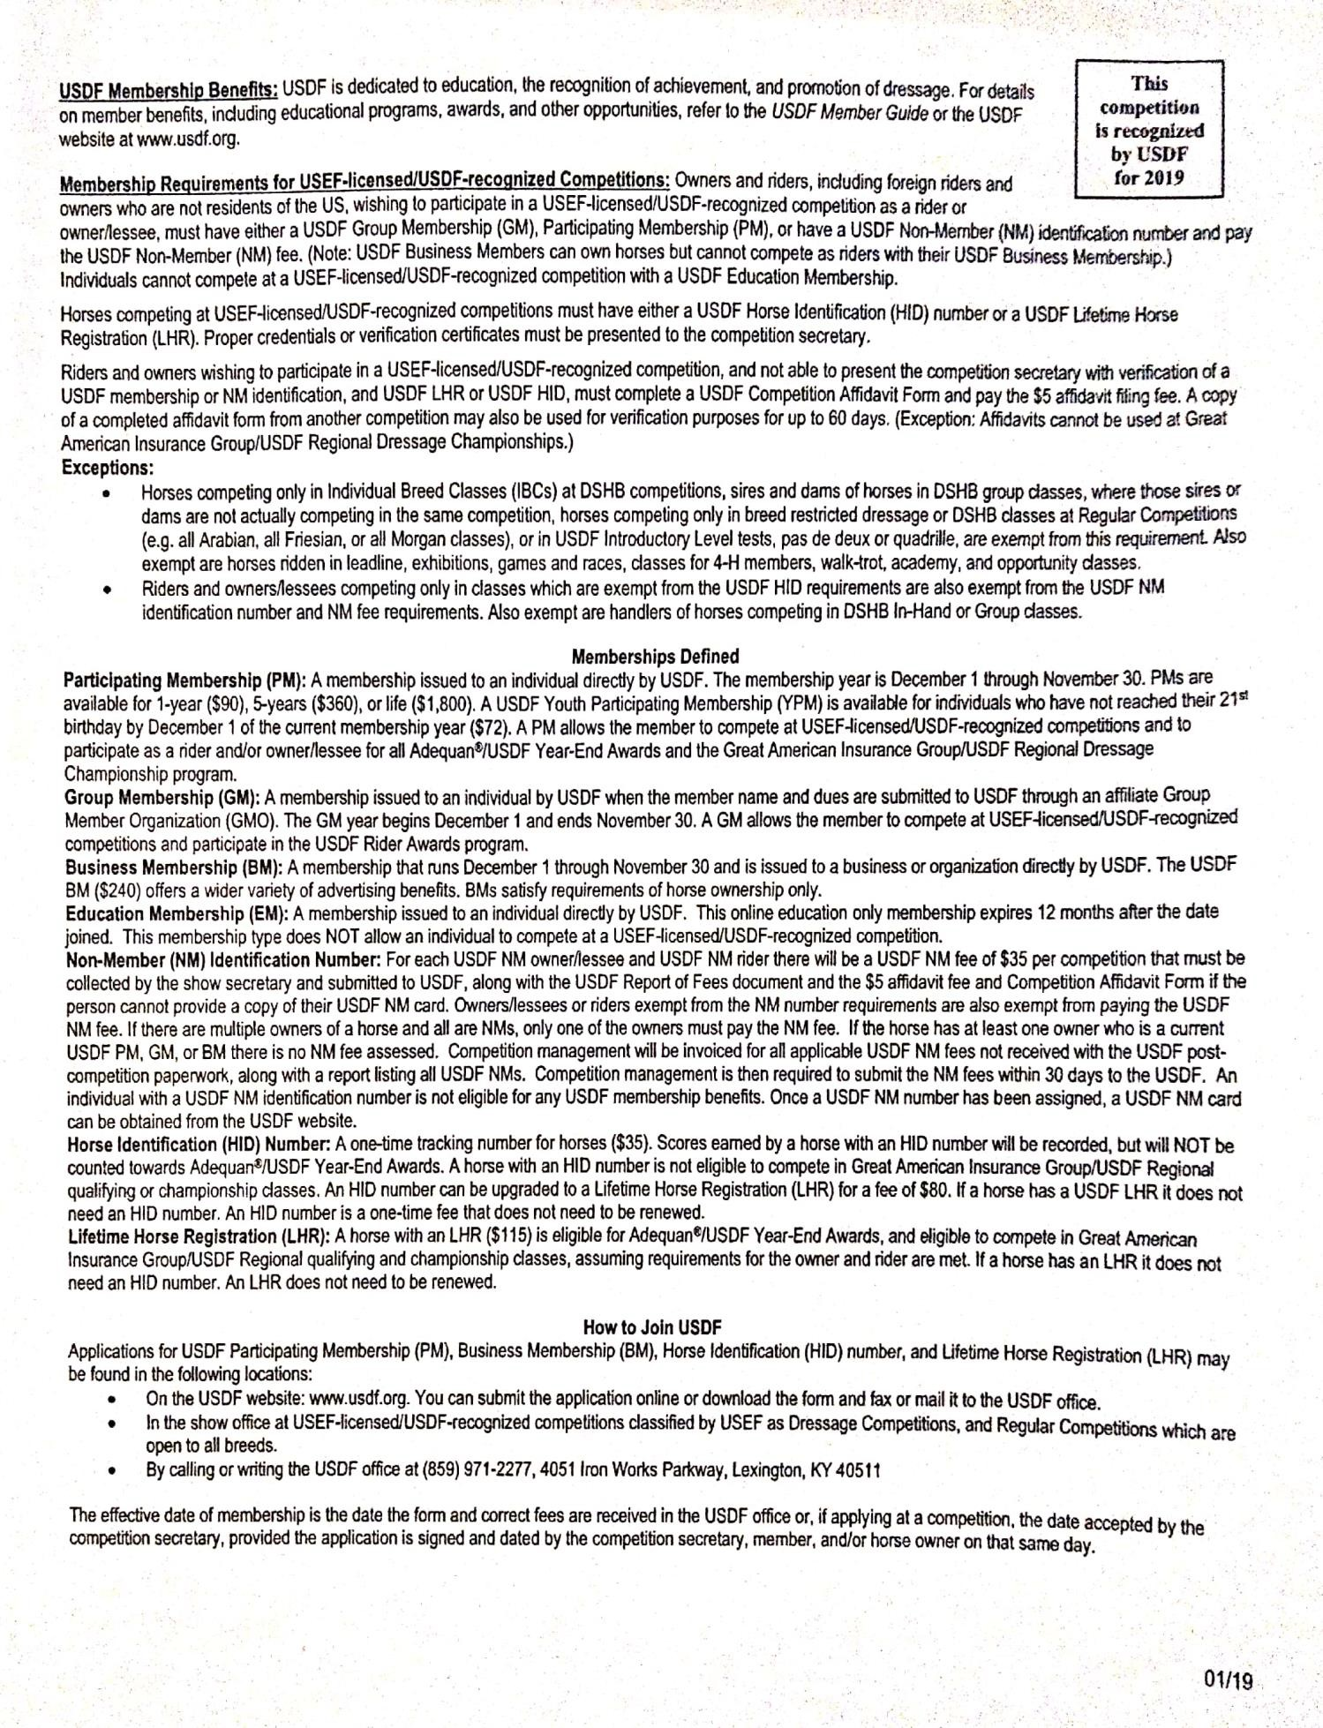

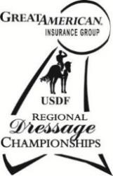
2019 Great American Insurance Group/USDF Regional Dressage Championships
A single Regional Dressage Championship program organized by the United States Dressage Federation (USDF), and recognized by the United States Equestrian Federation, Inc. (USEF), will be held in each of the nine USDF regions. In addition, Alaska and Hawaii may each hold state championships if an official request from a Group Member Organization (GMO) is received by April 1 of the prior year. The Regional Championship Program Rules can be found on the USDF website at www.usdf.org. Please refer to the 2019 USDF Member Guide for the comprehensive list of rules and requirements for this program.

Membership/Registration Requirements for Qualifying and Championships

All memberships and registrations/recordings must be correct and current at the time qualifying scores are earned and at the time of the championships.

Rider:
  - Must have a USDF Participating* Membership (PM).
  - Must have a USEF membership (Junior Active, Senior Active, or Life). Horse:
  - Must have a USDF Lifetime Horse Registration (LHR).
  - Must have a USEF (Annual or Lifetime) Horse recording.
  - USDF horse registration and USEF horse recording must be in the name(s) of the current owner(s) or lessee(s) of record. A horse is not required to have breed registry papers.
Owner:
  - Must have a USDF Participating or Business Membership and a USEF membership (Junior Active, Senior Active, Life, or Recorded Farm (with Active Farm Owner)). If the horse has more than one owner, at least one owner must have both active USEF membership and active USDF Participating or Business Membership and must be the owner of record with USEF and USDF. For a business or farm to be the valid owner under this requirement, it must be listed as an owner of the horse with both USEF and USDF.
- PMs are USDF members who join USDF directly. USDF Group Members (GM) are ineligible.

Minimum Qualifying Scores: One set of nationally-standardized qualifying scores has been established for all USEF/USDF Regional Championships, for Training Level through Grand Prix, in three divisions: open, adult amateur and junior/young rider. FEI Junior and FEI Young Rider classes have only one respective division. Freestyles have only open divisions.

The minimum percentages are as follows:
 | OPEN | AA | JR/YR
Training Level (Test 3) | 68% | 63% | 63%
First Level (Test 3) | 66% | 62% | 62%
Second Level (Test 3) | 64% | 61% | 61%
Third Level (Test 3) | 62% | 60% | 60%
Fourth Level (Test 3) | 62% | 60% | 60%
FEI Junior (Team Test) | — | — | 60%
FEI Young Rider (Team Test) | — | — | 60%
Prix St. Georges | 62% | 60% | 60%
Intermediate I | 62% | 60% | 60%
Intermediate II | 62% | 60% | 60%
Grand Prix | 60% | 60% | 60%
FREESTYLE | OPEN | AA | JR/YR
First Level | 65% | — | —
Second Level | 65% | — | —
Third Level | 65% | — | —
Fourth Level | 65% | — | —
Intermediate I | 65% | — | —
Grand Prix | 65%

USDF Statement on Animal Welfare
The United States Dressage Federation, Inc. (USDF), a federation of over 100 independent organizations throughout the United States with a membership of nearly 30,000 members, supports the concept of ethical treatment of animals.
Dressage is a classical method of training horses, based upon the horse’s natural responses, as carried out in a gradual, planned program during which the horse’s athletic abilities are improved in a systematic manner. As a result, the horse becomes capable, comfortable, and responsive in partnership with the rider without the use of force. Dressage competition at various levels of achievement is the ultimate test of the training program to determine whether the desired harmony between horse and rider has been achieved.
The rules pertaining to dressage competition prohibit the use of artificial appliances, training aids, and drugs, which would force the horse to submit. Instead, the emphasis is upon training and a cooperative partnership with the rider. Major competitions are carefully monitored to assure that there is no unnecessary force or harshness displayed.
Unlike other horse sports in which horses enter training at a relatively immature state, dressage training is usually not seriously begun until the horse is three or four. The top levels of achievement require five or more years of progressive training and it is not unusual to see horses in international competition in their late teens. This, in itself, places a premium on good care and soundness throughout the horse’s life.
While supporting the concept of animal welfare in its broadest form, the United States Dressage Federation, Inc., also recognizes that it is unrealistic to ascribe human emotions and responses to the horse which in its wild state is a creature of flight, living a hard and precarious existence. Under domestication, the horse is assured of ample food, water, and shelter, as well as protection against infectious diseases and damaging parasites, thus leading a longer and healthier life with a high rate of survival.
As an educational organization, USDF has numerous programs, which teach people how to pursue the accepted, humane training methods. A program of certifying instructors also emphasizes protecting the horse’s welfare in pursuit of dressage training. United States Dressage Federation 4051 Iron Works Parkway, Lexington, KY 40511 Phone: 859-971- 2277, Fax: 859-971-7722, usdressage@usdf.org

Motor Vehicle Statement
Minors who do not have a valid driver's license which allows them to operate a motorized vehicle in the state in which they reside will not be permitted to operate a motorized vehicle of any kind, including, but not limited to, golf carts, motorcycles, scooters, or farm utility vehicles, on the competition grounds of licensed competitions. Minors who have a valid temporary license may operate the above described motorized vehicles as long as they are accompanied by an adult with a valid driver's license. The parent(s), legal guardian(s), or individual who signs the entry blank as a parent or guardian of a minor operating a motorized vehicle in violation of this rule are solely responsible for any damages, claims, losses or actions resulting from that operation. Violations of this rule will be cause for sanctions against the parent(s), guardian(s) and/or trainer(s) who are responsible for the child committing the offense. Penalties may include exclusion of the child, parent(s), guardian(s), and/or trainer(s) from the competition grounds for the remainder of the competition and charges being filed against any of the above individuals in accordance with Chapter 6. Wheelchairs and other mobility assistance devices for individuals with disabilities are exempt from this rule

USEF MEMBERSHIP STATEMENT
Life, senior active and junior active members shall be eligible to participate in all classes at Regular Competitions, Eventing Competitions at the Preliminary Level or above and Combined Driving Competitions at the Advanced Level, Dressage, Reining and Vaulting Competitions and Endurance Rides. A nonmember may participate as a handler, rider, driver, owner, lessee, agent, coach or trainer at Regular Competitions, Eventing Competitions, Dressage Competitions, Reining Competitions and Combined Driving Competitions upon payment of a $45 Show Pass fee. Participants in the following classes are exempted from the Requirements of this rule: 1) leadline; 2) exhibitions; 3) games and races; 4) classes for 4-H members; 5) walk trot (exception: Friesian performance FR222) and academy classes (academy classes are classes limited to horses used regularly in a lesson program); 6) USDF introductory level tests, pas de deux and quadrille classes; 7) NRHA Endorsed Reining Competitions. 8) Opportunity classes, 9) citizens of other nations who have proof, in English, of current membership in good standing of their own National Federation, 10) USEA beginner novice division; and 11) assistant handlers in Dressage Sport Horse Breeding classes.

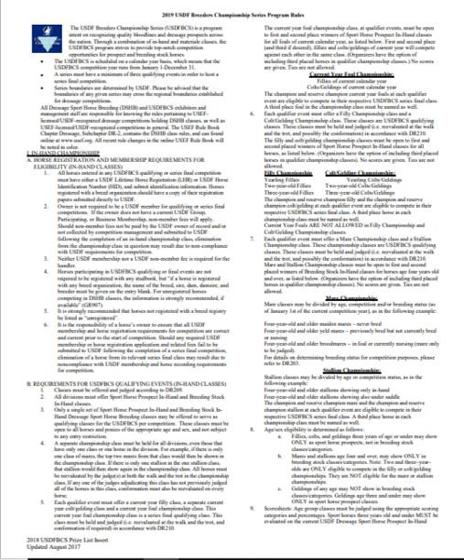

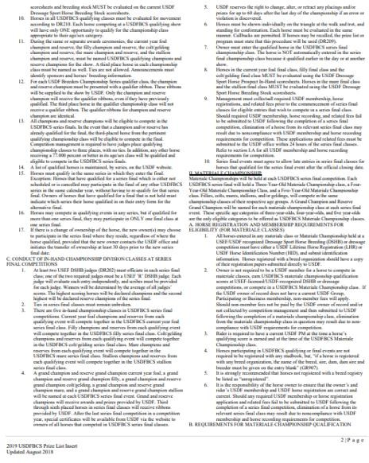

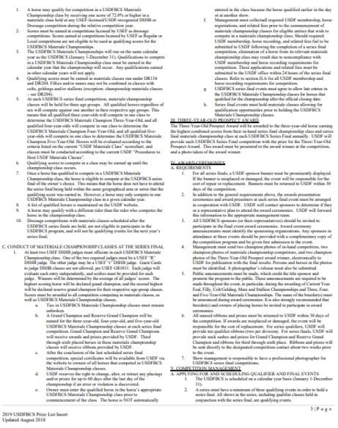

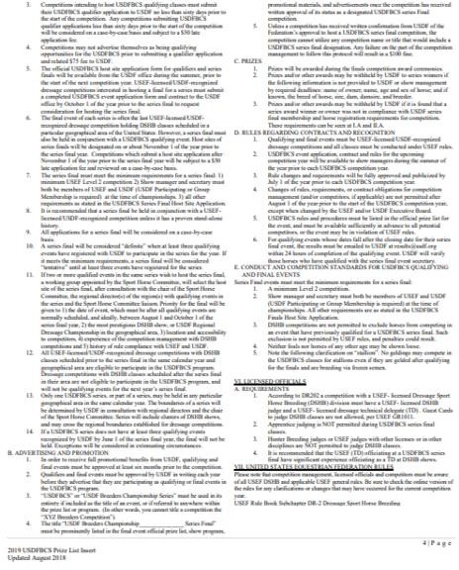

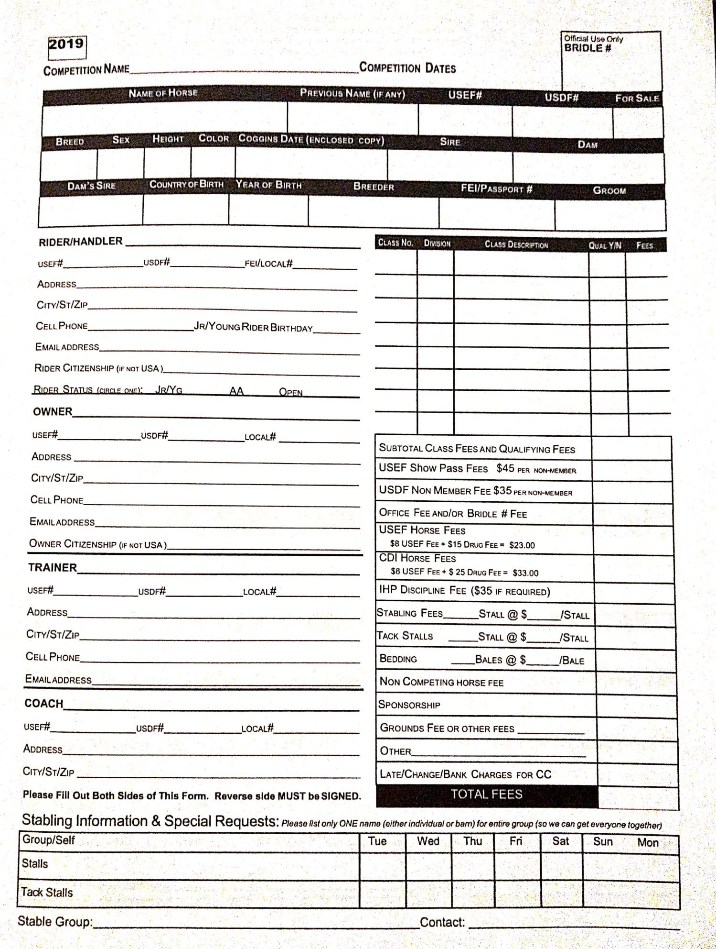

Dressage at the Park July 6-7, 2019

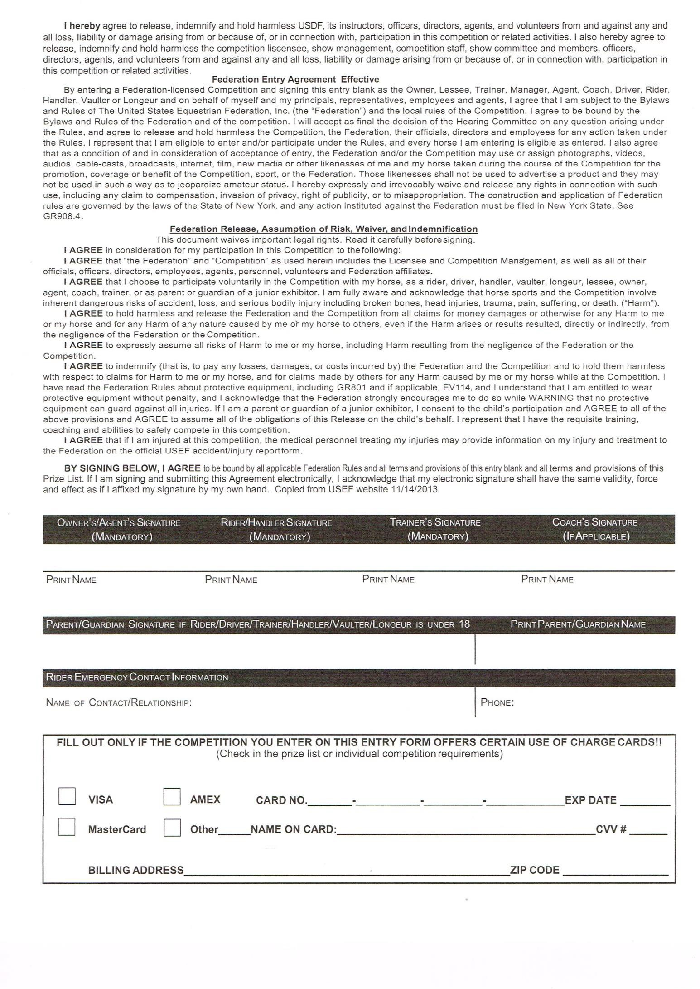

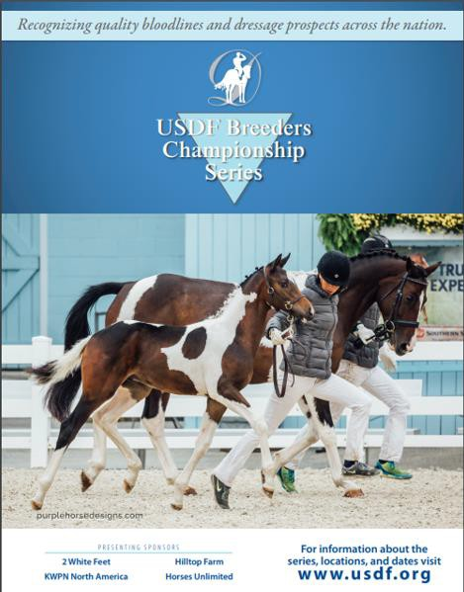

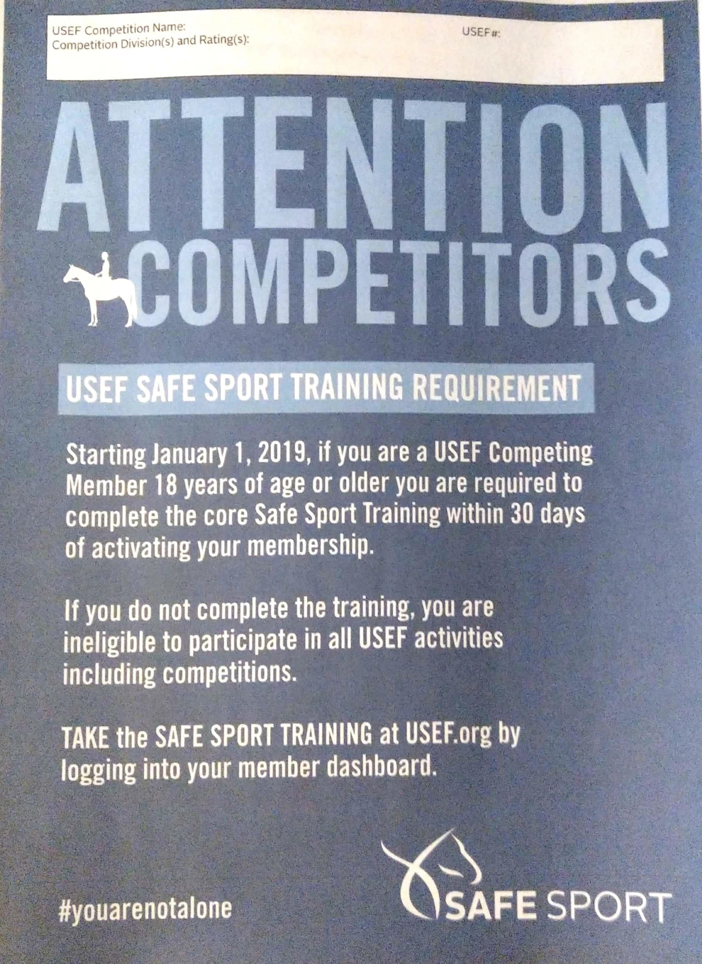
Dressage at the Park 286066
USDF Training Level – Grand Prix, FEI tests Level 3 Competition & Breed Show

