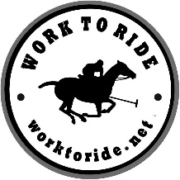
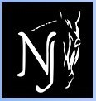
Dressage at Stone Tavern
Matchy Matchy Parade!
INFORMATION & RULES

Dressage at Stone Tavern is pleased to announce the Second Matchy-Matchy Parade!

The parade will take place during the lunch break on Saturday, September 10th.

The parade is open to children (and adults) of all ages. Participants are encouraged to decorate themselves and their horses with a Matchy-Matchy theme. Creativity is encouraged, however please no costumes that may spook or frighten other horses.

Those without a horse wishing to participate can do so with a stick horse or a model horse.

All participants will receive a gift. There is no fee to participate, however, participants are strongly encouraged to raise funds on behalf of our featured charity, the "Work to Ride" program.

There will be awards for most funds raised in each age group. Participants are encouraged to be creative in their fundraising, e.g. having a "pony wash" or running a "carrot & cookie stand" at the barn.

All horses must have current negative coggins and Flu/Rhino vaccinations within 6 months per USEF regulations. Pre-registration is not required, but is suggested. Registration forms can be found at https://horseparkofnewjersey.wildapricot.org/dressage-at-stone-tavern

More information on the Work to Ride Program

Founded in 1994, Work to Ride (WTR) is a 501 c3, nonprofit community-based prevention program that aids under-resourced urban youth through constructive activities centered on horsemanship, equine sports and education. The program is housed at Chamounix Equestrian Center, located in West Fairmount Park, Philadelphia. This setting provides a unique opportunity to bring urban youth in contact with animals and nature.

For more information, visit https://worktoride.net Join the conversation at:

Facebook – https://www.facebook.com/work.ride/
Instagram – https://www.instagram.com/worktoride1/

